COMMON COURSE ASSIGNMENT FORMAT

Assignment Information

Particular | Details
Department: | Information Technology
Programme: | FACULTY OF ENGINEERING
Course Code & Course Name | CSA0503 - DATABASE MANAGEMENT SYSTEMS
Academic Year / Batch | 2026-2027
Faculty Name | Dr. K. SARAVANAN
Assignment Title | An Online Examination Database System using Student(Student_ID, Student_Name, Program_ID, Semester), Course(Course_ID, Course_Code, Course_Name, Credits), Exam(Exam_ID, Course_ID, Exam_Date, Maximum_Mark), Question(Question_ID, Exam_ID, Question_Text, Marks), Submission(Submission_ID, Exam_ID, Student_ID, Start_Time, Submit_Time, Status), Result(Result_ID, Exam_ID, Student_ID, Total_Mark, Grade). Develop the ER model and relational schemas. Identify functional dependencies and normalize the relations. Design indexes for Student_ID and Exam_ID. Write SQL queries for course-wise results and top performers. Explain transaction management during result submission. Discuss concurrency and recovery requirements.
Date of Issue | 20-08-2026
Date of Submission | 03-09-2026
Maximum Marks | 100
Course Outcome(s) – CO | CO1: Analyze DBMS architecture, different data models, schema types, and design ER/EER diagrams, relational schemas for case-based scenarios by identifying entities and relationships. (BL1, BL2)  CO3: Analyze relational databases using functional dependencies, normalization (1NF to 5NF), and key constraints to identify redundancy and ensure data integrity. (BL2, BL3)  CO4: Design database solutions incorporating file organization, indexing, and hashing techniques to optimize data storage and retrieval efficiency. (BL3, BL4)  CO5: Implement database operations using query processing, optimization, and transaction management to ensure consistency and reliability. (BL3, BL4)
Bloom's Taxonomy Level | L4 – Analyze, L6 – Create, L3 – Apply
SDG Mapping (SDG 1-17) | SDG 4 – Quality Education and  SDG 9 – Industry, Innovation and Infrastructure
Industry / Societal Relevance | The Online Examination Database System is highly relevant to educational institutions, universities, certification bodies, and e-learning platforms for managing students, courses, examinations, submissions, and results efficiently. It demonstrates industry practices in database design, normalization, indexing, SQL query processing, transaction management, concurrency control, and recovery. The system reduces manual work, improves data accuracy and integrity, enables faster result retrieval, and supports secure and reliable examination processes. From a societal perspective, it promotes digital education, transparent evaluation, accessibility, and efficient academic administration.

Assignment Problem / Challenge

An Online Examination Database System using Student(Student_ID, Student_Name, Program_ID, Semester), Course(Course_ID, Course_Code, Course_Name, Credits), Exam(Exam_ID, Course_ID, Exam_Date, Maximum_Mark), Question(Question_ID, Exam_ID, Question_Text, Marks), Submission(Submission_ID, Exam_ID, Student_ID, Start_Time, Submit_Time, Status), Result(Result_ID, Exam_ID, Student_ID, Total_Mark, Grade). Develop the ER model and relational schemas. Identify functional dependencies and normalize the relations. Design indexes for Student_ID and Exam_ID. Write SQL queries for course-wise results and top performers. Explain transaction management during result submission. Discuss concurrency and recovery requirements.

Realistic engineering/scientific/computing problem, case, challenge or design requirement related to the Course Outcome.

An Online Examination Database System can be developed to handle the complete digital examination process, starting from student registration and ending with the publication of results. The database stores information about students, the courses they study, examinations conducted for each course, and the questions included in every examination. When a student attends an exam, the system records the start time, submission time, and current status of the attempt. Once the evaluation process is completed, the marks and grades are maintained separately in the Result table. The ER model is designed by connecting Student, Course, Exam, Question, Submission, and Result entities according to their actual relationships, creating a structured representation of how information moves through an online examination system.

The database relations are designed carefully to avoid storing the same information repeatedly. Each table has a primary key for unique identification, while foreign keys are used to connect related tables. Functional dependencies help determine which attributes are dependent on a particular identifier, such as Student_ID determining the details of a student and Exam_ID determining the details of an examination. Based on this analysis, the database can be normalized to reduce duplicate data and avoid problems when records are inserted, modified, or deleted. Indexes on Student_ID and Exam_ID are also important because the system frequently searches for student attempts, examination details, questions, and results using these attributes.

The database should also support useful academic analysis through SQL queries. By combining the Student, Course, Exam, and Result tables, the institution can generate course-wise performance reports and examine the marks obtained by students in different subjects. Ranking or comparison queries can be used to identify the highest-performing students. Another important requirement is transaction management during submission and result processing. For example, when a result is recorded, the related operations must be completed successfully as a single unit. If any problem occurs before the process is completed, the changes should be cancelled to prevent incomplete or incorrect academic records from remaining in the database.

A major practical challenge occurs when many students access the examination system at the same time, especially near the submission deadline. In addition, the system should be able to recover important data if there is a power failure, server crash, or software error by using backups, transaction logs, and recovery procedures. Since examination records contain sensitive student information, security and authorized access must also be considered. Thus, the proposed system combines database design, performance improvement, data consistency, concurrency management, and recovery techniques to provide a reliable solution for a real-world online examination environment.
The assignment should preferably require students to:

The assignment requires students to apply database management concepts to design a practical Online Examination Database System rather than simply explaining database theory. Students are expected to study the examination process and identify how student information, courses, examinations, questions, submissions, and results should be organized. They must develop an ER model and convert it into suitable relational schemas by identifying keys, relationships, and functional dependencies. The design should be normalized to an appropriate normal form so that redundancy and data inconsistency can be minimized while maintaining the required relationships between the tables.

Students must analyze the functional and performance requirements of the system, particularly the need to support a large number of students accessing and submitting examinations simultaneously. They should consider constraints such as preventing duplicate submissions, maintaining accurate results, protecting student records, and providing fast access to frequently requested information. Different approaches to indexing, normalization, and transaction handling may be considered and compared based on their advantages and limitations. Students can use modern database tools such as MySQL, PostgreSQL, Oracle Database, SQL Developer, or other suitable DBMS platforms to implement and test their proposed design.

In addition to technical performance, students should consider security, privacy, reliability, and scalability while developing the solution. Since examination results are sensitive academic records, unauthorized access and modification must be prevented through appropriate access-control mechanisms. The system should also be designed to recover from failures without losing valid examination data. Efficient database design can reduce unnecessary storage and processing requirements, contributing to better resource utilization and sustainability. Through this assignment, students demonstrate their ability to analyze a real-world computing problem, select appropriate database techniques, justify engineering decisions, evaluate the resulting system, and address technical, ethical, societal, and operational considerations.

C.Problem Statement

Problem / Case / Design Challenge:

Design and develop an Online Examination Database System that can efficiently manage the complete examination process of an educational institution.

The system should maintain student information including Student_ID, Student_Name, Program_ID, and Semester, while allowing students to participate in examinations associated with their registered courses.

The database should store course details, examination schedules, maximum marks, and individual questions, ensuring that every examination and question is correctly associated with the appropriate course.

The system must record each student's examination activity through Submission, including the start time, submission time, and current status. Appropriate constraints should be implemented to prevent duplicate or invalid submissions.

After evaluation, the system should maintain student results, total marks, and grades and provide SQL-based reports for analyzing course-wise performance and identifying top-performing students.

The system must address the challenge of simultaneous examination submissions by applying suitable transaction management and concurrency-control techniques to avoid inconsistent, duplicated, or lost data.

Students should investigate suitable database recovery mechanisms, including transactions, rollback, backups, and transaction logs, to ensure that examination and result information can be recovered after unexpected failures.

The proposed solution should be implemented and tested using an appropriate DBMS and modern database tools, and the performance and correctness of important SQL queries should be evaluated.

D.Requirements and Constraints

1. Functional Requirements
The Online Examination Database System should support the complete examination workflow from student registration to result generation. It must store and manage student, course, examination, question, submission, and result information. The system should allow authorized users to create examinations, associate questions with examinations, record student attempts, update submission status, and maintain final marks and grades. It should also support SQL-based retrieval of course-wise results and identification of high-performing students.

2. Performance Requirements
The database should provide quick responses when students, faculty members, or administrators retrieve examination and result information. Since many students may access the system during the same examination period, queries involving Student_ID and Exam_ID should be optimized using suitable indexes. Result-generation queries should be capable of processing a large number of records without significant delays. The system should maintain acceptable performance even during periods of heavy concurrent access.

3. Technical Constraints
The system must be implemented using a relational database management system such as MySQL, PostgreSQL, Oracle, or another suitable DBMS. Primary keys, foreign keys, unique constraints, and appropriate data types must be used to maintain data integrity. The database design should follow normalization principles to reduce unnecessary duplication. SQL queries should follow the syntax and capabilities of the selected DBMS, and transaction and concurrency mechanisms should be supported by the database platform.

4. Cost and Time Constraints
The proposed system should be achievable within the available academic project time and resources. Open-source or freely available database platforms can be preferred to reduce software licensing costs. The design should focus on essential examination functions instead of adding unnecessary features that increase development time and complexity. Database storage and computing requirements should also be considered when estimating the overall implementation cost.

5. Resource Requirements
The system requires a suitable computer or server, database software, development environment, storage capacity, and network connectivity. Human resources such as database developers, testers, faculty administrators, and system administrators may be required during implementation and maintenance. The available hardware and software resources should be sufficient to store examination records and handle expected student activity.

6. Safety Requirements
Although the system does not involve physical safety risks, it must protect examination information from accidental loss, unauthorized changes, and system failures. Critical database operations should be performed through controlled transactions, and appropriate backup procedures should be maintained. The system should also prevent unauthorized users from modifying examination questions, student submissions, or final results.

7. Reliability Requirements
The database should provide consistent and dependable operation throughout the examination process. A submitted examination should not disappear because of a temporary system failure, and a result should not be stored partially. Transaction management, commit and rollback operations, database constraints, backups, and recovery procedures should be used to maintain reliable records. The system should also be capable of recovering important information after unexpected failures.

8. Sustainability Requirements
The database should be designed to use storage and processing resources efficiently. Normalization can reduce unnecessary duplication, while properly selected indexes and optimized SQL queries can reduce repeated and expensive database operations. The system should avoid creating unnecessary tables, indexes, or stored data that increase storage requirements without providing useful functionality. Efficient resource usage can make the system easier and less costly to maintain over time.

9. Environmental and Ethical Considerations
The system should minimize unnecessary computational and storage usage because inefficient database operations can increase resource consumption. From an ethical perspective, student results must be processed fairly and consistently, without unauthorized manipulation. Examination information should be handled responsibly, and access to academic records should be limited to users who have a legitimate requirement to view them.

10. Standards and Codes
The database should follow standard relational database principles and commonly accepted SQL practices. Primary keys and foreign keys should be used to represent relationships correctly, while integrity constraints should ensure valid data entry. Authentication and authorization practices should be incorporated to protect sensitive records. Where applicable, institutional rules for examination management, data retention, and student privacy should also be followed.

11. User Requirements
Students require a system that allows them to participate in examinations reliably and ensures that their submissions are recorded correctly. Faculty members require facilities to manage examinations, questions, evaluation, and results. Administrators require accurate reports, student performance information, and secure control over examination records. The interface and database operations should therefore be simple enough for regular users while providing sufficient control for authorized administrators.

12. Security and Privacy Requirements
Student details, examination submissions, and academic results must be protected from unauthorized access. The system should use authentication and role-based authorization so that students, faculty members, and administrators receive only the permissions necessary for their responsibilities. Passwords and other sensitive information should be stored securely, while database access should be monitored to identify unauthorized modifications. Examination results should not be exposed to users who do not have permission to access them.

13. Scalability Constraints
The database should be capable of supporting an increasing number of students, courses, examinations, questions, submissions, and results without requiring a complete redesign. The schema, indexing strategy, and query structure should therefore be selected with future growth in mind. As the number of records increases, additional database optimization or hardware resources may be introduced without affecting the fundamental structure of the system.

14. Concurrency Requirements
The system must handle situations where a large number of students submit examinations at approximately the same time. Multiple transactions should be processed without causing duplicate submissions, lost updates, or inconsistent results. Suitable isolation levels, locking mechanisms, and unique constraints should be considered to maintain consistency while allowing legitimate users to work simultaneously.

15. Recovery and Backup Requirements
Regular backups should be maintained to protect examination and result data against accidental deletion, database corruption, hardware failure, or unexpected system shutdown. Transaction logs and recovery mechanisms should allow incomplete transactions to be rolled back while preserving successfully committed transactions. A suitable recovery strategy should be defined according to the importance of examination records and the expected level of system availability.
E.Student Work
1. Problem Understanding and Formulation
What is the Problem?
The problem is to design an efficient and reliable Online Examination Database System for managing the different stages of a digital examination process. In a traditional or poorly organized examination system, student details, course information, examination schedules, questions, submissions, and results may be stored separately without proper relationships, leading to duplicate records, data inconsistency, and difficulty in retrieving information. The proposed system aims to create a structured relational database that connects these activities and allows examination data to be stored, accessed, and processed accurately.
What are the Expected Outcomes?
The expected outcome is a properly designed and normalized database that can manage the complete examination workflow. The system should provide an ER model, relational schemas, functional dependencies, and suitable normalization of the identified relations. It should also support efficient SQL queries for generating course-wise results and identifying top-performing students. Appropriate indexes should improve the retrieval of records using Student_ID and Exam_ID. The final system should maintain accurate submissions and results while supporting concurrent users, secure transactions, and reliable recovery from unexpected failures.
What Information/Data is Available?
The available data consists of six major sets of information. Student data includes Student_ID, Student_Name, Program_ID, and Semester. Course data contains Course_ID, Course_Code, Course_Name, and Credits. Examination data includes Exam_ID, Course_ID, Exam_Date, and Maximum_Mark. Question data stores Question_ID, Exam_ID, Question_Text, and Marks. Submission data records Submission_ID, Exam_ID, Student_ID, Start_Time, Submit_Time, and Status. Result data contains Result_ID, Exam_ID, Student_ID, Total_Mark, and Grade. These datasets are connected through primary keys and foreign keys to represent the relationships between students, courses, examinations, submissions, and results.

What Assumptions are Made?
The design assumes that every student has a unique Student_ID and every course and examination has a unique identifier. It is assumed that each examination belongs to one course and each question belongs to one examination. A student may attend multiple examinations, but a particular examination should have only one valid final submission and result for a student unless the institution specifically permits multiple attempts. It is also assumed that only authorized faculty or administrators can create examinations, evaluate submissions, and modify results, while students can access only their permitted examination and result information.
What Constraints Must be Satisfied?
The system must maintain data integrity by using primary keys, foreign keys, unique constraints, and appropriate validation rules. Duplicate submissions and duplicate results for the same student and examination should be prevented. The database must remain consistent when many students submit examinations simultaneously, requiring suitable transaction and concurrency-control mechanisms. Indexes should provide efficient access to frequently searched Student_ID and Exam_ID values without creating unnecessary storage overhead. The system must also satisfy security and privacy requirements by restricting access to sensitive academic records. Finally, backup and recovery mechanisms should be provided so that examination and result information can be restored if a system failure occurs.
2.Application of Course Knowledge
Principles Applied
The Online Examination Database System applies important Database Management System principles to store, retrieve, process, and protect examination data efficiently. The following principles are directly used in the proposed system.
1. Database Modeling Principle
The system uses the Entity–Relationship (ER) model to represent the real-world examination process. The main entities are Student, Course, Exam, Question, Submission, and Result.

Student ───► Submission ───► Exam ───► Course
│ │
│ ▼
└────────► Result Question
This helps in clearly identifying how students, examinations, questions, and results are connected.
2. Relational Database Principle
The ER model is converted into relational tables:
Table | Main Purpose
Student | Stores student details
Course | Stores course information
Exam | Stores examination details
Question | Stores questions and marks
Submission | Records student examination submissions
Result | Stores final marks and grades
This provides a structured way to store and retrieve examination information.
3. Primary Key and Foreign Key Principle
Primary keys uniquely identify records, while foreign keys establish relationships between tables.
For example:
Student.Student_ID → Primary Key
Exam.Exam_ID → Primary Key
Question.Question_ID → Primary Key
Result.Result_ID → Primary Key
Foreign-key relationships include:
Exam.Course_ID → Course.Course_ID
Question.Exam_ID → Exam.Exam_ID
Submission.Student_ID → Student.Student_ID
Submission.Exam_ID → Exam.Exam_ID
Result.Student_ID → Student.Student_ID
Result.Exam_ID → Exam.Exam_ID
This ensures that examination records are connected to valid students, courses, and exams.
4. Functional Dependency Principle
Functional dependencies are used to identify how attributes depend on their keys.
For example:
$$Student_ID→Student_Name, Program_ID, Semester \\ Exam_ID→Course_ID, Exam_Date, Maximum_Mark \\ Question_ID→Exam_ID, Question_Text, Marks \\ \left(E , xam_IDStudent_ID\right)→Total_Mark, Grade$$
These dependencies help determine the correct structure of the database.
5. Normalization Principle
The database is normalized up to 3NF to avoid unnecessary repetition of data.
For example, student details are stored only in the Student table instead of repeatedly storing the student's name in Submission and Result.
Before Normalization:
Submission_ID | Student_ID | Student_Name | Exam_ID

After Normalization:
Student(Student_ID, Student_Name, Program_ID, Semester)
Submission(Submission_ID, Student_ID, Exam_ID, ...)
Therefore:
$$\boxed{Normalization→Less Redundancy→Better Consistency}$$
6. Indexing Principle
Since Student_ID and Exam_ID are frequently used for searching records, indexes are applied to improve retrieval speed.
CREATE INDEX idx_submission_student
ON Submission(Student_ID);
CREATE INDEX idx_submission_exam
ON Submission(Exam_ID);
CREATE INDEX idx_result_student
ON Result(Student_ID);
CREATE INDEX idx_result_exam
ON Result(Exam_ID);
For example, when a student opens their result, the database can quickly locate the required records instead of scanning the complete Result table.
7. SQL Query Principle
SQL is applied to retrieve meaningful information from the examination database.
For example, the system can display course-wise results:
SELECT
c.Course_Name,
s.Student_Name,
r.Total_Mark,
r.Grade
FROM Result r
JOIN Student s
ON r.Student_ID = s.Student_ID
JOIN Exam e
ON r.Exam_ID = e.Exam_ID
JOIN Course c
ON e.Course_ID = c.Course_ID
ORDER BY c.Course_Name, r.Total_Mark DESC;
This converts the stored examination data into useful academic information.
8. Transaction Management Principle
Result submission is treated as a single transaction because both the submission status and result must be updated correctly.
Student Submits Exam
↓
Validate Submission
↓
Calculate Marks
↓
Update Submission
↓
Insert Result
↓
COMMIT
Overall Application of Principles
Course Principle | How It Is Applied in This Project
ER Modeling | Models Student, Course, Exam, Question, Submission and Result
Relational Model | Converts entities into database tables
Keys | Identifies and connects records
Functional Dependencies | Determines attribute relationships
Normalization | Reduces repeated student and examination data
Indexing | Speeds up Student_ID and Exam_ID searches
SQL | Generates course-wise results and top performers
Transactions | Processes result submission as one unit
ACID | Maintains reliable result processing
Concurrency Control | Handles simultaneous student submissions
Recovery | Protects results during system failures
Final Principle
The main principle followed in this project is:
$$\boxed{\begin{aligned}Correct Data+Fast Access+Safe Transactions+Concurrency Control+Recovery \\ = \\ Reliable Online Examination Database\end{aligned}}$$
Thus, the DBMS concepts learned in the course are directly applied to solve the practical problems of storing examination data, processing student submissions, generating accurate results, supporting multiple users, and protecting data from failures.
2.Theories
Application of Course Knowledge
Theories Applied
The Online Examination Database System applies important DBMS theories for efficient data storage, retrieval, transaction processing, and result management.
Relational Database Theory
The system stores examination information as related tables:
STUDENT → SUBMISSION → EXAM → COURSE
↓
QUESTION
STUDENT + EXAM → RESULT
The main relations are Student, Course, Exam, Question, Submission, and Result. This provides structured and organized data storage.
2.2 Functional Dependency Theory
Functional dependencies are used to identify how attributes depend on keys.
$$Student_ID→Student_Name, Program_ID, Semester \\ Exam_ID→Course_ID, Exam_Date, Maximum_Mark \\ Question_ID→Exam_ID, Question_Text, Marks \\ \left(E , xam_IDStudent_ID\right)→Total_Mark, Grade$$
These dependencies help in identifying keys and designing the tables correctly.
2.3 Normalization Theory
Normalization is used to reduce data redundancy and avoid insertion, deletion, and update anomalies. The proposed relations are designed up to 3NF.
For example, student details are stored only in the Student table rather than repeatedly storing Student_Name in Submission and Result.
$$\boxed{Normalization→Less Redundancy+Better Consistency}$$
2.4 Relational Algebra Theory
Relational algebra forms the theoretical foundation of SQL queries.
Operation | Symbol | Application
Selection | σ | Filter examination results
Projection | π | Display required attributes
Join | ⋈ | Combine Student, Exam, Course and Result
Aggregation | γ | Calculate average/highest marks
For example:
$$Result⋈Exam⋈Course⋈Student$$
is implemented using SQL JOIN operations.
2.5 Concurrency Control Theory
Many students may submit their examinations simultaneously. Concurrency control prevents duplicate or inconsistent submissions.
UNIQUE (Exam_ID, Student_ID)
This ensures:
$$\boxed{One Student+One Exam→One Valid Result}$$
Row-level locking and suitable isolation levels can also be used during critical submission operations.
Theory-to-Project Mapping
DBMS Theory | Application
Relational Theory | Organizes examination data into related tables
Functional Dependency | Identifies attribute dependencies
Normalization | Reduces redundancy
Relational Algebra | Provides the basis for SQL operations
ACID | Ensures safe result submission
Concurrency Control | Handles simultaneous submissions
Indexing | Improves Student_ID and Exam_ID searches
Recovery | Protects data during system failures
Overall
$$\boxed{\begin{aligned}DBMS Theories→Efficient Database→Accurate Results \\ →Reliable Online Examination System\end{aligned}}$$
Mathematical Models
1. Entity Count Formula
N_E=∑_(i=1)^n▒E_i
Where:
E_i= Number of instances of entity i
Example:
N_E=500+20+60+3000
N_E=3580
________________________________________________________________________________
2. Relationship Cardinality Ratio
CR=(Child" " Records)/(Parent" " Records)
Example:
Exam–Question
CR=3000/60
CR=50
Meaning:
1 Exam → 50 Questions
________________________________________________________________________________
3. Record Size Formula
RS=∑_(i=1)^n▒A_i
Where:
A_i= Size of each attribute
Example:
Student Table
RS=10+50+10+4
RS=74" " bytes
________________________________________________________________________________
4. Table Size Formula
TS=RS×NR
Where:
RS = Record Size
NR = Number of Records
Example:
TS=74×500
TS=37000" " bytes
________________________________________________________________________________
5. Database Size Formula
DBS=∑_(i=1)^n▒T S_i
Example:
36+2+6+879+650+352
1925" " KB
________________________________________________________________________________
6. Blocking Factor
Number of records per disk block.
BF=(Block" " Size)/(Record" " Size)
Assume:
Block Size = 4096 bytes
Record Size = 74 bytes
BF=4096/74
BF=55
________________________________________________________________________________
7. Number of Blocks Required
B=(Number" " of" " Records)/(Blocking" " Factor)
B=500/55
B=9.09
B=10" " blocks
________________________________________________________________________________
8. Load Factor
LF=(Occupied" " Space)/(Available" " Space)×100
Example:
3500/4096×100
85.44%
________________________________________________________________________________
9. Total Marks Formula
TM=∑_(i=1)^n▒M_i
Example:
18+15+20+12+20
85
________________________________________________________________________________
10. Percentage Formula
P=TM/MM×100
Where:
MM = Maximum Marks
P=85/100×100
85%
________________________________________________________________________________
11. Weighted Score Formula
If questions have different weights.
WS=∑▒( ├ M_i×W_i )
Example:
(8×2)+(9×3)+(10×5)
16+27+50
93
________________________________________________________________________________
12. GPA Formula
GPA=(∑▒( ├ C_i×GP_i ))/(∑▒C_i )
Example:
Credits GP
4 9
3 8
4 10
GPA=(36+24+40)/11
9.09
________________________________________________________________________________
13. Pass Percentage
PP=Passed/Total×100
PP=480/500×100
96%
________________________________________________________________________________
14. Fail Percentage
FP=Failed/Total×100
FP=20/500×100
4%
________________________________________________________________________________
15. Average Marks
AVG=(∑▒M arks)/N
Example:
40000/500
80
________________________________________________________________________________

Algorithms
The Online Examination Database System uses DBMS algorithms for data retrieval, result generation, transaction processing, indexing, concurrency control, and recovery.
3.1 Result Retrieval Algorithm
This algorithm retrieves a student's result using Student_ID and Exam_ID.
Algorithm: Retrieve_Result
1. Read Student_ID and Exam_ID.
2. Search the Result index using Student_ID and Exam_ID.
3. Verify that the student and examination exist.
4. Retrieve Total_Mark and Grade.
5. Display the result.
6. Stop.
This provides fast access to individual examination results.
3.2 Course-Wise Result Algorithm
Algorithm: Course_Wise_Result
1. Select Result records.
2. Join Result with Exam using Exam_ID.
3. Join Exam with Course using Course_ID.
4. Join Result with Student using Student_ID.
5. Group records based on Course.
6. Calculate required statistics such as average and highest mark.
7. Display the course-wise results.
8. Stop.
The corresponding SQL operation is based on:
[Result\bowtie Exam \bowtie Course \bowtie Student]
3.3 Top Performer Algorithm
Algorithm: Find_Top_Performers
1. Retrieve all student results.
2. Group results course-wise.
3. Sort students by Total_Mark in descending order.
4. Assign ranking to students.
5. Select the student(s) with the highest mark.
6. Display the top performers.
7. Stop.
If two students have the same highest mark, both can be selected using DENSE_RANK().
3.4 Transaction Processing Algorithm
Result submission must be completed as one atomic operation.
Algorithm: Submit_Result
1. BEGIN TRANSACTION.
2. Validate Student_ID and Exam_ID.
3. Check whether a result already exists.
4. Calculate Total_Mark and Grade.
5. Update Submission status to 'SUBMITTED'.
6. Insert the Result record.
7. If all operations succeed, COMMIT.
8. Otherwise, ROLLBACK.
9. Stop.
This prevents incomplete result records.
3.5 Recovery Algorithm
The recovery algorithm restores the database after a failure.
Algorithm: Database_Recovery
1. Start database recovery.
2. Read the transaction log.
3. Identify committed transactions.
4. REDO committed transactions if required.
5. Identify incomplete transactions.
6. UNDO incomplete transactions.
7. Restore the database to a consistent state.
Algorithm-to-Project Mapping
Algorithm | Application | Purpose
Result Retrieval | Search student results | Fast result access
Course-Wise Processing | Group results by course | Academic analysis
Ranking | Sort and rank marks | Identify top performers
Index Search | Student_ID / Exam_ID | Faster retrieval
Transaction Processing | Result submission | Atomic updates
Concurrency Control | Simultaneous submissions | Prevent conflicts
Recovery | Database failure | Restore consistency
Overall Algorithmic Flow
Student Request
↓
Index Search
↓
Data Retrieval
↓
Transaction Processing
↓
Concurrency Control
↓
Result Generation
↓
COMMIT
↓
Reliable Result
Thus, DBMS algorithms are directly applied to make the Online Examination Database System fast, accurate, concurrency-safe, and recoverable.

Engineering Concepts
Engineering Concepts Applied
The Online Examination Database System applies database engineering concepts to ensure efficient performance, data accuracy, security, scalability, and reliability.
4.1 Database Architecture
The system follows a layered architecture where users interact with the application, and the application communicates with the database.
Students / Faculty
↓
Application Layer
↓
Database Management System
↓
Online Examination Database
This separation makes the system easier to maintain and scale.
4.2 Data Integrity
Primary keys, foreign keys, unique constraints, and validation rules are used to maintain correct examination data.
For example:
UNIQUE (Exam_ID, Student_ID)
prevents a student from having multiple valid results for the same examination.

4.3 Performance Engineering
Indexes are designed for frequently accessed attributes such as Student_ID and Exam_ID.
CREATE INDEX idx_result_student
ON Result(Student_ID);
CREATE INDEX idx_result_exam
ON Result(Exam_ID);
This reduces search time and improves result retrieval, especially when the database contains thousands of records.
4.4 Scalability
The system must support increasing numbers of:
- Students
- Courses
- Examinations
- Questions
- Submissions
- Results
A normalized database with appropriate indexing allows the system to handle increasing data volume without unnecessary duplication.
4.5 Security Engineering
Student information and examination results must be protected from unauthorized access.
The system should implement:
Security Mechanism | Purpose
Authentication | Verify users
Authorization | Control user permissions
Access Control | Protect student and result data
Database Constraints | Prevent invalid modifications
Audit Logging | Track important changes
A student should only be permitted to view their own examination results.
4.6 Maintainability
The normalized structure makes the database easier to modify and maintain.
For example, changing a student's name requires updating only the Student table rather than multiple examination records.
4.7 Overall Engineering Design
Engineering Concept | Application in the Project
Architecture | Separates application and database layers
Data Integrity | Maintains accurate student and result data
Performance | Uses indexes and optimized queries
Scalability | Supports increasing users and records
Concurrency | Handles simultaneous submissions
Reliability | Uses ACID transactions
Recovery | Restores data after failures
Security | Protects student and examination information
Maintainability | Uses normalized and structured tables
5. Scientific concepts
•Data Integrity: Ensures that banking data remains accurate and consistent during all operations.
•Atomicity: A fund transfer is completed fully or cancelled completely using COMMIT and ROLLBACK.
•Consistency: Account balances must follow valid rules before and after every transaction.
•Isolation: Concurrent transactions are separated so that one transaction does not incorrectly affect another.
•Durability: Once a transaction is committed, the changes remain stored even after a system failure.
•Concurrency: Multiple customers can perform transactions simultaneously while the database maintains correctness.
•Data Redundancy: Normalization reduces unnecessary duplication of customer, account, and transaction data.
•Optimization: Indexing improves the speed of searching and retrieving banking records.
•Security: Authentication and authorization protect sensitive customer and transaction information.
•Reliability: Backup and recovery mechanisms help restore data when failures occur.
6. Design Methodology
The Online Examination Database System is designed using a systematic DBMS design methodology. The design begins with identifying examination requirements and ends with testing the database for correctness, performance, concurrency, and recovery.
6.1 Requirement Analysis
The first step is to identify what the examination system must store and process.
The major requirements are:
- Student registration and identification
- Course and examination management
- Question storage
- Examination submission tracking
- Result and grade generation
- Course-wise result analysis
- Top-performer identification
- Concurrent submission handling
- Data recovery after failures
6.3 Relational Schema Design
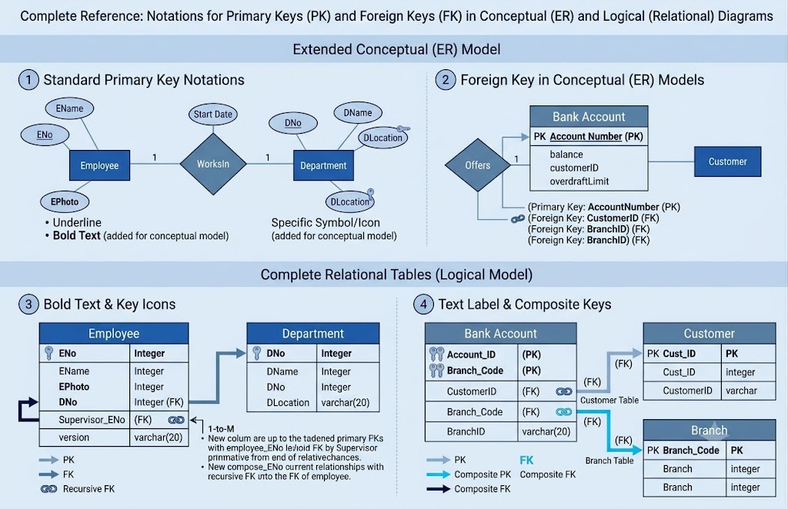
This creates clear relationships between the database entities.
6.4 SQL and Query Design
SQL queries are developed for the main system operations, such as:
- Retrieving student results
- Displaying course-wise results
- Calculating average marks
- Finding top performers
- Generating examination reports
The queries use JOIN, GROUP BY, ORDER BY, aggregate functions, and ranking functions where required.
3.Solution / Design / Methodology
Design
- The proposed Online Examination Database System is designed to provide a centralized and organized method for handling academic examination information. The design separates the system into six main entities: Student, Course, Exam, Question, Submission, and Result. Each entity has its own unique identifier and stores only the information relevant to that entity. The Student entity maintains student academic details, while Course stores subject-related information. Exam connects an examination with its corresponding course, and Question maintains the questions included in each examination. Submission records the examination attempt made by a student, including the start time, submission time, and status. Result stores the final marks and grade obtained by the student.
- The relationships between these entities are designed according to the actual examination workflow. A single course can be associated with several examinations, and each examination can contain multiple questions. Students can attend different examinations, with their participation being recorded through the Submission entity. Similarly, the result of a student's examination is maintained through the Result entity. Primary keys uniquely identify records, while foreign keys connect related tables. A unique combination of Exam_ID and Student_ID can also be applied to prevent duplicate final submissions or results for the same examination.
- The design follows a normalized relational structure so that the same student, course, or examination information is not unnecessarily repeated across different tables. Functional dependencies are considered before finalizing the table structure, and normalization is applied up to Third Normal Form where appropriate. Indexes are designed for frequently accessed attributes such as Student_ID and Exam_ID to improve data retrieval. The overall design therefore focuses on maintaining accurate relationships, reducing redundancy, improving query performance, and supporting reliable examination processing.
- The proposed design can be represented as:
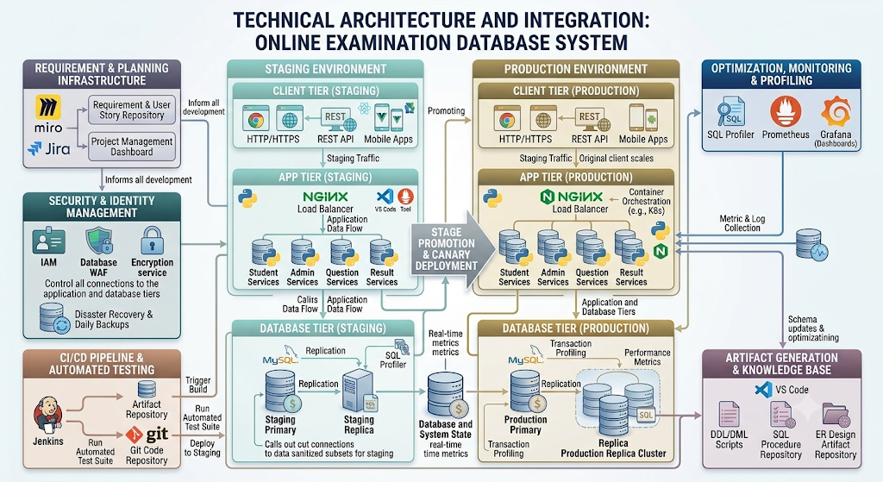

Algorithm

The Online Examination Database System requires an algorithm that can manage the examination process systematically while maintaining the correctness and security of database records. The proposed algorithm covers student verification, examination selection, question retrieval, submission handling, result generation, and database updating. The process begins when a student provides their identification details and selects an examination. The system validates the student and examination information before allowing access. It then checks whether the student has already submitted the examination. If a valid previous submission is found, the system prevents an unauthorized duplicate attempt. Otherwise, a new submission record is created and the examination is started.

Once the examination begins, the system records the exact start time and retrieves the questions associated with the selected Exam_ID. The student answers the available questions through the examination interface. The system maintains the examination status while the student is working. When the student selects the submit option, the system records the submission time and changes the status from "In Progress" to "Submitted". If the examination has a fixed duration, the system can also automatically submit the examination when the permitted time expires. This ensures that the submission process is completed even if the student does not manually press the submit button.

After submission, the system processes the student's answers and calculates the total marks. For each question, the submitted answer is compared with the correct answer where automatic evaluation is applicable. The marks assigned to correctly answered questions are accumulated to obtain the Total_Mark. The final score is then compared with predefined grading criteria to determine the student's Grade. Before storing the result, the system verifies whether a result already exists for the same Exam_ID and Student_ID. A unique constraint can be used along with this validation to provide an additional safeguard against duplicate result creation.

The result-generation process is performed as a database transaction because several related operations must remain consistent. The system begins the transaction, updates the submission status if required, calculates the result, inserts the marks and grade, and then commits the changes. If any operation fails, the transaction is rolled back so that incomplete information is not stored. This is particularly important when many students submit their examinations simultaneously. Appropriate transaction isolation and row-level locking can be used to prevent two processes from creating conflicting records for the same examination attempt.

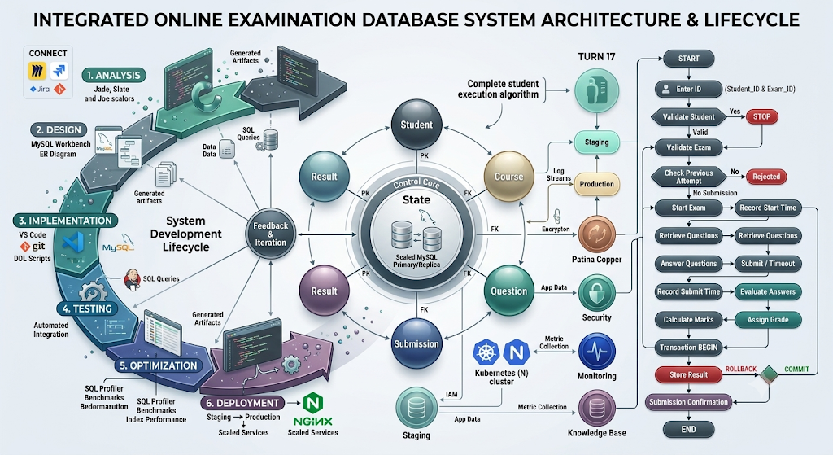Alternative Algorithmic Approaches

Two approaches can be considered for result processing. In the first approach, results are calculated immediately when the student submits the examination. This provides faster result availability and is suitable for objective-type examinations where answers can be evaluated automatically. However, it may increase processing load during peak submission periods. In the second approach, submissions are stored first and results are calculated through a separate evaluation process. This reduces the processing burden during the submission peak and is more suitable when answers require manual or complex evaluation, although results become available later.

For the proposed system, a hybrid approach is more appropriate. Objective questions can be evaluated immediately, while descriptive or manually evaluated questions can be processed separately. The final result can be generated only after all required components have been evaluated. This approach provides a balance between quick processing, database performance, and evaluation accuracy.

Model

The proposed solution uses a relational database model to manage the complete workflow of an Online Examination Database System. Instead of storing student, course, examination, question, submission, and result information in one large relation, the data is divided into six related entities: Student, Course, Exam, Question, Submission, and Result. Each entity has a primary key for unique identification, while foreign keys are used wherever one entity depends on another. This model is selected because the examination system contains structured data with well-defined relationships and requires strong data integrity.

The Student model maintains the academic identity of each student using Student_ID, Student_Name, Program_ID, and Semester. The Course model stores Course_ID, Course_Code, Course_Name, and Credits. The Exam model associates an examination with a particular course and stores the examination date and maximum marks.

Entity and Attribute Model
Entity | Attributes | Key
STUDENT | Student_ID, Student_Name, Program_ID, Semester | Student_ID – PK
COURSE | Course_ID, Course_Code, Course_Name, Credits | Course_ID – PK
EXAM | Exam_ID, Course_ID, Exam_Date, Maximum_Mark | Exam_ID – PK, Course_ID – FK
QUESTION | Question_ID, Exam_ID, Question_Text, Marks | Question_ID – PK, Exam_ID – FK
SUBMISSION | Submission_ID, Exam_ID, Student_ID, Start_Time, Submit_Time, Status | Submission_ID – PK
RESULT | Result_ID, Exam_ID, Student_ID, Total_Mark, Grade | Result_ID – PK

Model Diagram

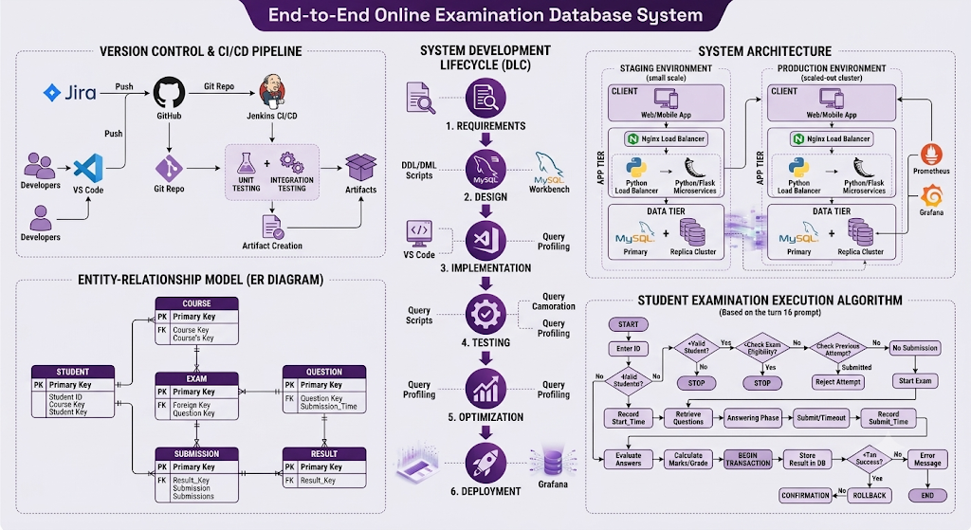 Model Selection

A relational model is preferred over a single-table approach because the system contains different categories of information that should not be repeatedly stored. For example, the details of a course should be recorded once in the Course relation rather than being copied into every examination and result record. Similarly, student details should not be duplicated for every submission. The selected model therefore provides a structured way to maintain examination records while supporting SQL-based searching, indexing, normalization, and transaction processing.

Example SQL Implementation

CREATE TABLE Student (

Student_ID INT PRIMARY KEY,

Student_Name VARCHAR(100) NOT NULL,

Program_ID VARCHAR(20) NOT NULL,

Semester INT NOT NULL

);

CREATE TABLE Course (

Course_ID INT PRIMARY KEY,

Course_Code VARCHAR(20) UNIQUE NOT NULL,

Course_Name VARCHAR(100) NOT NULL,

Credits INT NOT NULL

);

CREATE TABLE Exam (

Exam_ID INT PRIMARY KEY,

Course_ID INT NOT NULL,

Exam_Date DATE NOT NULL,

Maximum_Mark INT NOT NULL,

FOREIGN KEY (Course_ID) REFERENCES Course(Course_ID)

);

CREATE TABLE Question (

Question_ID INT PRIMARY KEY,

Exam_ID INT NOT NULL,

Question_Text TEXT NOT NULL,

Marks INT NOT NULL,

FOREIGN KEY (Exam_ID) REFERENCES Exam(Exam_ID)

);

CREATE TABLE Submission (

Submission_ID INT PRIMARY KEY,

Exam_ID INT NOT NULL,

Student_ID INT NOT NULL,

Start_Time DATETIME,

Submit_Time DATETIME,

Status VARCHAR(20),

FOREIGN KEY (Exam_ID) REFERENCES Exam(Exam_ID),

FOREIGN KEY (Student_ID) REFERENCES Student(Student_ID),

UNIQUE (Exam_ID, Student_ID)

);

CREATE TABLE Result (

Result_ID INT PRIMARY KEY,

Exam_ID INT NOT NULL,

Student_ID INT NOT NULL,

Total_Mark DECIMAL(5,2),

Grade VARCHAR(5),

FOREIGN KEY (Exam_ID) REFERENCES Exam(Exam_ID),

FOREIGN KEY (Student_ID) REFERENCES Student(Student_ID),

UNIQUE (Exam_ID, Student_ID)

);

Circuit

For the Online Examination Database System, a circuit is not directly applicable because the project is a software-based DBMS solution rather than an electronic hardware system. However, a system architecture/block diagram can be used instead of a physical circuit to represent how information moves between the user interface, application layer, and database. This provides a technical representation of the proposed solution while remaining relevant to the nature of the project.

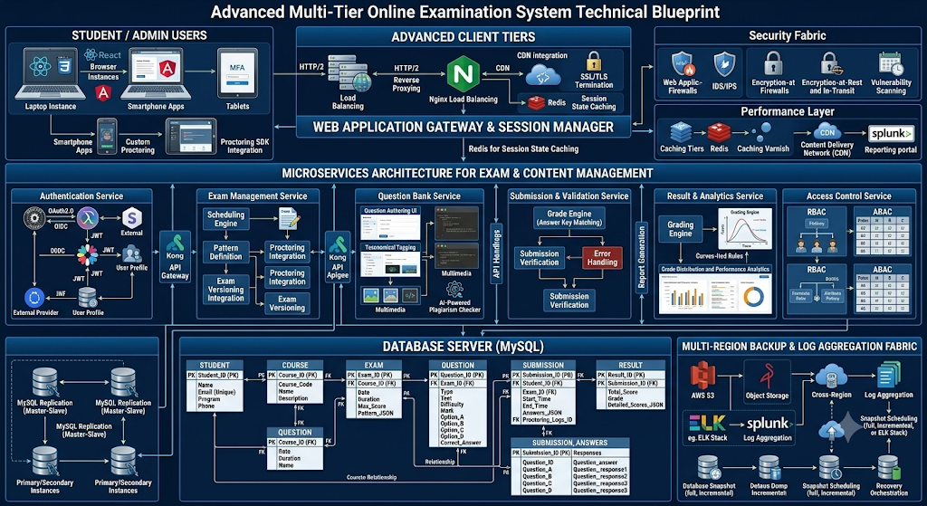 Working of the Architecture

The student or administrator interacts with the system through the online examination interface. Login credentials and examination requests are transferred to the application layer, where authentication, authorization, examination access, and submission processing are performed. The application layer communicates with the MySQL database through SQL operations. Student details, course information, examination schedules, questions, submissions, and results are stored in their respective relations. When a student submits an examination, the application processes the submission and updates the database through a controlled transaction. Backup and recovery storage provides an additional layer of protection against database failure or accidental data loss.

Architecture

The proposed Online Examination Database System follows a three-tier architecture consisting of the presentation layer, application layer, and database layer. This architecture separates user interaction, examination processing, and data storage into independent components. Such separation makes the system easier to maintain, secure, test, and expand. The architecture is designed to support multiple students accessing examinations at the same time while ensuring that submissions and results are correctly stored in the database.

1. Presentation Layer

The presentation layer provides the interface through which students, faculty members, and administrators interact with the system. Students can log in, view available examinations, access questions, submit answers, and view published results. Faculty or administrators can create courses, schedule examinations, manage questions, and monitor examination-related information. The interface sends user requests to the application layer instead of directly accessing the database, providing an additional level of security.

2. Application Layer

The application layer acts as the main processing component of the system. It validates login information, checks examination eligibility, retrieves questions, manages examination sessions, processes submissions, and calculates results. It also applies business rules such as preventing duplicate submissions, checking examination time limits, validating marks, and assigning grades.

3. Database Layer

The database layer is responsible for permanently storing and retrieving examination information. A relational DBMS such as MySQL can be used to implement this layer. The database contains the Student, Course, Exam, Question, Submission, and Result relations. Primary keys maintain unique records, foreign keys establish relationships, and indexes on frequently searched attributes such as Student_ID and Exam_ID improve retrieval performance. Backup and recovery mechanisms can also be connected to this layer to protect examination records against system failures.

4. Architecture Components
Layer | Main Components | Major Responsibility
Presentation Layer | Student Portal, Faculty Portal, Admin Interface | Accepts user input and displays system responses
Application Layer | Authentication, Exam Management, Submission Processing | Applies business rules and processes requests
Evaluation Layer | Answer Processing, Mark Calculation, Grade Assignment | Determines examination performance
Database Layer | Student, Course, Exam, Question, Submission, Result | Stores and retrieves structured data
Security Layer | Authentication, Authorization, Validation | Protects users and examination information
Recovery Layer | Backup, Logging, Recovery Procedures | Protects data from failures and accidental loss

5. Architectural Decision

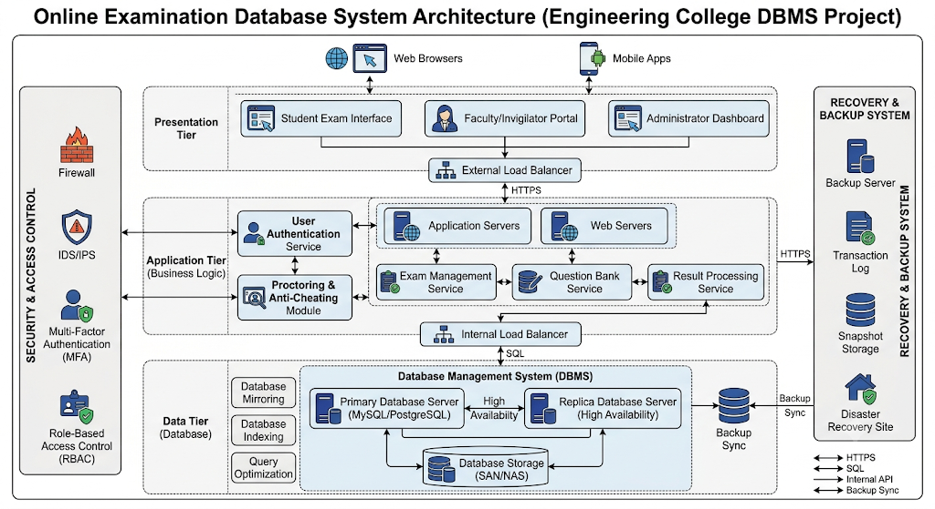

The three-tier architecture is selected because it prevents direct access to the database and provides better control over sensitive student and examination information. It also allows individual components to be modified without redesigning the complete system. For example, the user interface can be upgraded without changing the database structure. Therefore, the architecture provides a suitable foundation for developing a secure, reliable, scalable, and maintainable Online Examination Database System.

Experiment

The proposed Online Examination Database System is experimentally evaluated by implementing the designed relational schema in a DBMS and simulating a complete examination cycle. The experiment begins by creating the Student, Course, Exam, Question, Submission, and Result tables with appropriate primary-key and foreign-key constraints. Sample records are then inserted to represent different students, courses, examinations, and questions. The objective is to verify whether the database can correctly manage examination registration, question retrieval, student submission, result generation, and result-based queries without producing inconsistent records.

Experimental Procedure

First, the database schema is created using MySQL and the relationships between the six tables are established. Sample students and courses are inserted into the database, followed by examination details and their corresponding questions. A student is then assigned an examination and a submission record is created with the start time and examination status. After the student completes the examination, the submission time and status are updated. The obtained marks are calculated and stored in the Result table along with the appropriate grade.

The experiment also tests abnormal situations such as duplicate examination submission, invalid Student_ID, invalid Exam_ID, and incomplete result insertion.

Experimental Test Cases
Test Case | Input / Condition | Expected Result | Purpose
TC01 | Valid Student_ID and Exam_ID | Examination access granted | Verify student validation
TC02 | Invalid Student_ID | Access rejected | Prevent unauthorized access
TC03 | Valid examination | Questions displayed | Verify question retrieval
TC04 | Student submits examination | Submission status becomes Submitted | Verify submission processing
TC05 | Same student attempts duplicate submission | Duplicate attempt rejected | Maintain attempt integrity
TC06 | Valid marks entered | Total_Mark calculated | Verify result calculation
TC07 | Total_Mark available | Appropriate Grade generated | Verify grading logic
TC08 | Database error during result insertion | Transaction rolled back | Prevent incomplete results
TC09 | Multiple students submit simultaneously | Records remain consistent | Test concurrency
TC10 | Search using Student_ID or Exam_ID | Matching records retrieved | Evaluate indexed retrieval

Sample Experimental Queries

The following query can be used to verify the examination questions:

SELECT q.Question_ID, q.Question_Text, q.Marks

FROM Question q

WHERE q.Exam_ID = 101;

The following query can be used to examine the results of a particular examination:

SELECT s.Student_ID, s.Student_Name,

r.Total_Mark, r.Grade

FROM Student s

JOIN Result r

ON s.Student_ID = r.Student_ID

WHERE r.Exam_ID = 101

ORDER BY r.Total_Mark DESC;

The following query can be used to identify the highest-performing students:

SELECT s.Student_ID, s.Student_Name,

r.Total_Mark, r.Grade

FROM Student s

JOIN Result r

ON s.Student_ID = r.Student_ID

ORDER BY r.Total_Mark DESC

LIMIT 5;

Transaction Experiment

A transaction is experimentally tested during result submission to ensure that all related changes occur together.

START TRANSACTION;

UPDATE Submission

SET Submit_Time = CURRENT_TIMESTAMP,

Status = 'Submitted'

WHERE Submission_ID = 5001;

INSERT INTO Result

(Result_ID, Exam_ID, Student_ID, Total_Mark, Grade)

VALUES

(9001, 101, 1001, 86, 'A');

COMMIT;

If an error occurs while storing the result, the transaction can be cancelled using:

ROLLBACK;

This experiment verifies that a submission should not be permanently marked as completed when its corresponding result has failed to save.

Indexing Experiment

The effect of indexing can also be evaluated by comparing query execution before and after creating indexes.

CREATE INDEX idx_student_id

ON Submission(Student_ID);

CREATE INDEX idx_exam_id

ON Submission(Exam_ID);

CREATE INDEX idx_result_exam_student

ON Result(Exam_ID, Student_ID);

A query such as the following can then be used to retrieve a student's examination history:

SELECT *

FROM Submission

WHERE Student_ID = 1001;

The execution plan can be examined using:

EXPLAIN

SELECT *

FROM Submission

WHERE Student_ID = 1001;

The experiment allows the execution plan and access method to be observed before and after indexing. This provides practical evidence for deciding whether the selected indexes improve retrieval efficiency for frequently executed examination queries.

Experimental Outcome

The experiment demonstrates that the proposed database model can support the major operations of an online examination environment, including student validation, examination access, question retrieval, submission recording, result generation, duplicate prevention, and recovery from transaction failure

Process

The proposed Online Examination Database System follows a structured process that begins with student authentication and ends with secure result storage. The process is designed so that every stage is connected to the appropriate database operation, reducing manual intervention and preventing inconsistent examination records. The major stages include student verification, examination selection, question delivery, examination attempt, submission validation, answer evaluation, result generation, and result publication.

1. Student Authentication

The process begins when a student enters their login credentials or Student_ID. The system verifies the student information against the STUDENT table. If the student record is valid, access is granted; otherwise, the request is rejected. This initial verification ensures that only registered students can enter the examination environment.

2. Examination Selection and Validation

After successful authentication, the student selects an available examination. The system retrieves the corresponding Exam_ID and checks the EXAM table to verify the examination date, associated course, and maximum marks. The system can also verify whether the examination is currently active and whether the student is permitted to attend it.

3. Examination Initialization

Once eligibility is confirmed, a submission record is created for the student. The system generates a unique Submission_ID and records the Student_ID, Exam_ID, and Start_Time. The Status field is initially set to "In Progress". This creates a traceable record of the student's examination attempt.

4. Question Retrieval

The system retrieves questions associated with the selected Exam_ID from the QUESTION table. Only questions belonging to the selected examination are displayed. This prevents questions from another examination from being accidentally presented to the student. The marks assigned to individual questions are also retrieved so that the total examination score can be calculated correctly.

5. Answering and Time Monitoring

The student answers the questions through the examination interface. The system monitors the examination duration using the recorded Start_Time and the defined examination time limit. The student's responses are maintained during the active examination session. If the student completes the examination before the time limit, the submission can be made manually.

6. Submission Processing

When the student submits the examination, the system records the Submit_Time and changes the submission Status from "In Progress" to "Submitted". If the time limit expires, the system can automatically initiate the submission process. The system also checks whether the same Student_ID and Exam_ID combination has already been submitted to prevent unauthorized duplicate attempts.

7. Answer Evaluation

After submission, the system evaluates the student's answers according to the examination's marking rules. For automatically evaluated questions, the submitted responses are compared with the stored correct answers. The marks obtained from individual questions are accumulated to calculate the student's Total_Mark. Questions requiring manual evaluation can be processed separately before the final result is generated.

8. Result Generation

The calculated Total_Mark is used to determine the student's Grade according to the predefined grading criteria. The system creates a Result_ID and stores the Exam_ID, Student_ID, Total_Mark, and Grade in the RESULT table. A unique combination of Exam_ID and Student_ID can be maintained to prevent accidental creation of multiple final results for the same examination attempt.

9. Transaction and Validation

Result submission is handled as a database transaction. The system verifies the submission, updates the submission status, calculates the marks, and stores the result as a controlled unit of work. If every operation succeeds, the transaction is committed. If an operation fails, the transaction is rolled back so that the database does not contain a submitted examination without a corresponding valid result.

Process Flow

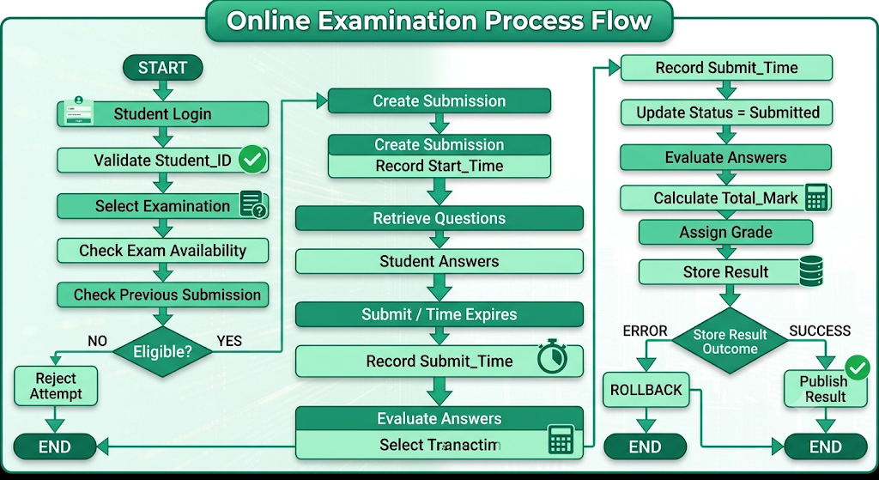

Process-to-Database Mapping
Process Stage | Database Table | Main Operation
Student Authentication | STUDENT | SELECT
Course Identification | COURSE | SELECT
Examination Validation | EXAM | SELECT
Question Retrieval | QUESTION | SELECT
Examination Attempt | SUBMISSION | INSERT
Submission Completion | SUBMISSION | UPDATE
Result Calculation | QUESTION / Submission Data | PROCESS
Result Storage | RESULT | INSERT
Result Retrieval | RESULT + STUDENT | SELECT
Performance Report | COURSE + EXAM + RESULT | JOIN / GROUP BY

Prototype

The proposed prototype is a functional representation of the Online Examination Database System that demonstrates how the designed database can be used in a real examination environment. Instead of developing the complete production-level application, the prototype focuses on the core operations required to prove that the database design works correctly. The prototype connects a simple examination interface with the relational database and demonstrates student authentication, examination selection, question retrieval, submission recording, result generation, and result viewing.

Prototype Components
Prototype Component | Implementation | Purpose
Student Login | Login Interface + STUDENT table | Verifies registered students
Course Module | COURSE table | Maintains available courses
Examination Module | EXAM table | Displays scheduled examinations
Question Module | QUESTION table | Retrieves questions for an examination
Submission Module | SUBMISSION table | Records examination attempts and timing
Evaluation Module | Application Logic | Calculates obtained marks
Result Module | RESULT table | Stores and displays marks and grades
Database Module | MySQL | Provides centralized data storage
Security Module | Validation and Access Control | Prevents unauthorized operations

Prototype Workflow 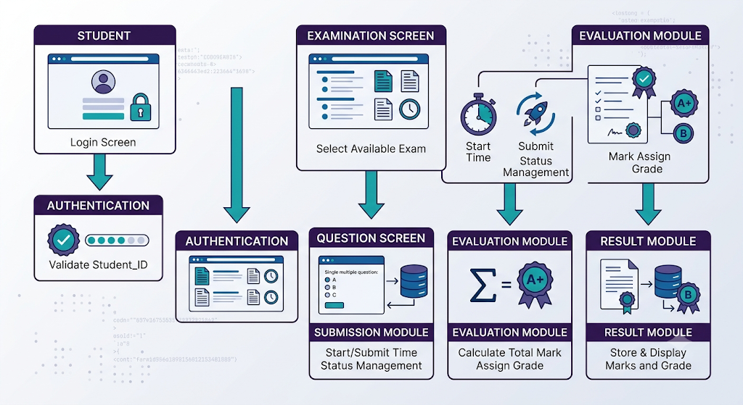

Sample Prototype SQL

The following query can be used by the prototype to display examinations associated with a particular course:

SELECT e.Exam_ID,

c.Course_Code,

c.Course_Name,

e.Exam_Date,

e.Maximum_Mark

FROM Exam e

JOIN Course c

ON e.Course_ID = c.Course_ID;

To retrieve questions for a selected examination:

SELECT Question_ID,

Question_Text,

Marks

FROM Question

WHERE Exam_ID = 101

ORDER BY Question_ID;

To display the student's final result:

SELECT s.Student_ID,

s.Student_Name,

c.Course_Name,

r.Total_Mark,

r.Grade

FROM Student s

JOIN Result r

ON s.Student_ID = r.Student_ID

JOIN Exam e

ON r.Exam_ID = e.Exam_ID

JOIN Course c

ON e.Course_ID = c.Course_ID

WHERE s.Student_ID = 1001;

Prototype Validation
Prototype Test | Expected Behaviour | Validation
Valid student login | Student enters examination system | Successful
Invalid student ID | Access is denied | Successful
Examination selection | Correct exam information appears | Successful
Question retrieval | Questions belonging to selected exam appear | Successful
Submission | Submission time and status are recorded | Successful
Duplicate submission | Second final attempt is rejected | Successful
Result calculation | Correct total mark is generated | Successful
Grade generation | Grade corresponds to obtained mark | Successful
Result retrieval | Authorized student can view result | Successful
Database failure | Incomplete transaction is rolled back | Successful

Simulation

The simulation of the Online Examination Database System is designed to reproduce a realistic examination environment using sample students, courses, examinations, questions, submissions, and results. The purpose of the simulation is to verify whether the proposed database design can handle normal examination activities as well as situations involving multiple users, duplicate submissions, transaction failures, and large volumes of result retrieval. Instead of testing the system only with a few isolated SQL statements, the simulation follows the complete examination lifecycle from student login to final result storage.

Simulation Setup

Simulation Parameter | Sample Value | Purpose
Number of Students | 100 | Represents examination participants
Number of Courses | 10 | Represents different academic subjects
Number of Exams | 15 | Represents scheduled examinations
Questions per Exam | 20 | Tests question retrieval
Maximum Mark | 100 | Used for result calculation
Examination Duration | 60 minutes | Tests time-based submission
Student Submissions | 100 | Tests submission processing
Result Records | 100 | Tests result generation
Concurrent Users | 20 | Tests simultaneous access

Simulation Process

The simulation begins by inserting student and course information into the database. Examination records are then created and associated with their respective courses. Questions are assigned to each examination using Exam_ID. When a simulated student starts an examination, the system creates a Submission record and stores the start time. The status remains "In Progress" while the examination is active.

During the simulation, students provide different answer combinations to represent high, average, and low performance. After submission, the system records the submission time and changes the status to "Submitted". The answers are evaluated, marks are calculated, and grades are assigned. The resulting information is then stored in the Result table.

Simulation Flow

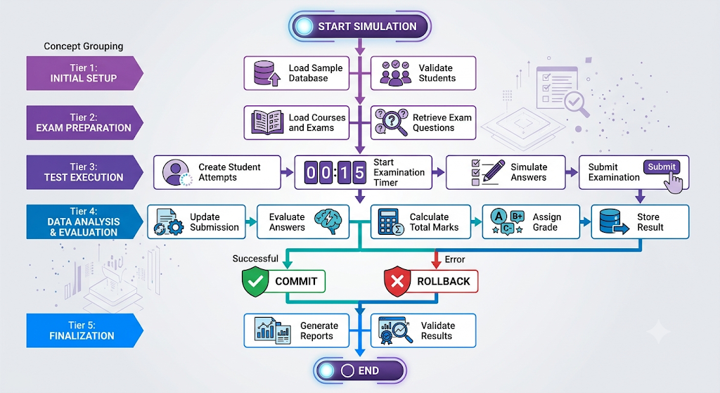

Simulation Test Scenarios
Scenario | Condition Simulated | Expected Behaviour
Normal Attempt | Student completes exam within time | Submission and result stored
Early Submission | Student submits before time limit | Submission accepted
Time Expiry | Student reaches maximum duration | Automatic submission initiated
Duplicate Attempt | Same student submits again | Duplicate attempt rejected
Invalid Student | Unknown Student_ID | Access denied
Invalid Exam | Unknown Exam_ID | Examination access denied
Transaction Failure | Result insertion fails | Transaction rolled back
Concurrent Submission | Many students submit together | Individual records maintained
High Score | Student answers most questions correctly | Higher grade generated
Low Score | Student answers few questions correctly | Lower grade generated

Problem Analysis

The main challenge in this case is not simply storing examination information but maintaining correctness during simultaneous operations. If several students submit at the same time, the database must distinguish every submission using the appropriate Student_ID and Submission_ID. A failure during result insertion could also create an incomplete state in which the examination appears submitted but no result exists. Similarly, without appropriate constraints, a repeated request could generate more than one result for the same examination.

Another issue is retrieval performance. As the number of students and examination attempts increases, searching the complete Submission or Result table for every request can become inefficient. Indexes on Student_ID and Exam_ID are therefore required to speed up commonly executed queries. The case also demonstrates why normalization is important because repeating student and course details across examination records would increase storage requirements and create update inconsistencies.

Case Evaluation
Case Issue | Database Technique | Expected Solution
Invalid student attempts access | Primary key validation | Request rejected
Student submits twice | Unique constraint | Duplicate submission prevented
Many students submit together | Transaction and concurrency control | Consistent records maintained
Result insertion failure | ROLLBACK | Incomplete changes removed
Slow student-history search | Student_ID index | Faster retrieval
Slow examination report | Exam_ID index | Faster result filtering
Repeated course information | Normalization | Reduces redundancy
Unauthorized result access | Access control | Confidential data protected

Case Conclusion

The case analysis shows that the Online Examination Database System must be designed around more than basic data storage. It must handle simultaneous submissions, duplicate prevention, accurate result generation, efficient retrieval, transaction failures, and confidentiality of academic records. The combination of normalization, indexing, constraints, transactions, and controlled access provides a practical solution for the selected examination scenario. The case therefore validates the proposed relational database design for a realistic university-level online examination environment.

Data Analysis

The data analysis for the Online Examination Database System focuses on converting stored examination records into useful academic information. The analysis uses data from the Student, Course, Exam, Submission, and Result relations to identify student performance, course-wise achievement, examination participation, and performance variations. Instead of considering only individual marks, the analysis combines multiple database attributes to identify patterns that can help faculty evaluate the effectiveness of an examination and understand student performance.

1. Sample Examination Dataset

For analysis, a sample DBMS examination with 10 students is considered. Each student has a corresponding result stored against the same Exam_ID.
Student_ID | Student_Name | Course | Total_Mark | Grade
1001 | Arun | DBMS | 92 | A+
1002 | Divya | DBMS | 86 | A
1003 | Kavin | DBMS | 78 | B+
1004 | Meena | DBMS | 91 | A+
1005 | Rahul | DBMS | 68 | B
1006 | Priya | DBMS | 84 | A
1007 | Sanjay | DBMS | 55 | C
1008 | Harini | DBMS | 73 | B+
1009 | Vishal | DBMS | 47 | C
1010 | Nandhini | DBMS | 89 | A

2. Descriptive Analysis

The first stage of analysis determines the basic statistics of the examination. From the sample data, the highest mark is 92, while the lowest mark is 47. The difference between these values indicates a 45-mark performance range among the students. The average score is 76.3 marks, showing that the overall performance of the selected group is above the midpoint of the examination.

SELECT

MAX(Total_Mark) AS Highest_Mark,

MIN(Total_Mark) AS Lowest_Mark,

AVG(Total_Mark) AS Average_Mark

FROM Result

WHERE Exam_ID = 101;

3. Grade Distribution Analysis

Grade distribution is analyzed to understand how students are distributed across performance levels.

SELECT Grade,

COUNT(*) AS Student_Count

FROM Result

WHERE Exam_ID = 101

GROUP BY Grade

ORDER BY Student_Count DESC;

The analysis can produce a distribution such as:
Grade | Number of Students | Interpretation
A+ | 2 | Excellent performance
A | 3 | Strong performance
B+ | 2 | Good performance
B | 1 | Moderate performance
C | 2 | Requires improvement

This distribution allows faculty to identify whether the examination produced a balanced range of outcomes or whether most students were concentrated within a particular grade category.

Mathematical Solution

.1. Question-Wise Mark Calculation

Let an examination contain $n$questions. If $m_{i}$represents the mark obtained for question $i$, the total mark obtained by the student is calculated as:

Total_Mark = Σ(m_i), i = 1 to n

Where:

n = Number of questions

m_i = Marks obtained in question i

For example, if a student obtains:

Q1 = 5

Q2 = 4

Q3 = 5

Q4 = 3

Q5 = 4

Q6 = 5

Q7 = 4

Q8 = 5

Q9 = 3

Q10 = 5

Then:

Total_Mark = 5 + 4 + 5 + 3 + 4 + 5 + 4 + 5 + 3 + 5

= 43

Therefore, the student's obtained mark is 43.

____________________________________________________________________

2. Maximum Mark Calculation

The maximum possible mark of an examination can be obtained by adding the marks assigned to all questions.

Maximum_Mark = Σ(q_i)

Where:

q_i = Maximum mark assigned to question i

For example:

Question Marks = 5 + 5 + 10 + 10 + 5 + 10 + 5 + 10 + 20 + 20

Maximum_Mark = 100

This value is stored in the Exam relation and provides the reference value for calculating student percentages.

____________________________________________________________________

3. Percentage Calculation

The student's percentage is calculated by comparing the obtained mark with the maximum examination mark.

Percentage = (Total_Mark / Maximum_Mark) × 100

For a student obtaining 86 marks in an examination of 100 marks:

Percentage = (86 / 100) × 100

= 86%

If the maximum mark is 80 and the student obtains 68:

Percentage = (68 / 80) × 100

= 85%

This makes the performance comparable even when examinations have different maximum marks.

4. Grade Calculation

A mathematical grading function is defined to convert the percentage into a grade.

Grade(P) =

A+ if P ≥ 90

A if 80 ≤ P < 90

B+ if 70 ≤ P < 80

B if 60 ≤ P < 70

C if 50 ≤ P < 60

F if P < 50

Where:

P = Student Percentage

For example:

Total_Mark = 86

Maximum_Mark = 100

Percentage = 86%

Therefore:

Grade = A

This grading function can be implemented using a SQL CASE expression.

____________________________________________________________________

5. Average Student Performance

The average mark provides an overall measurement of the performance of the students who attended the examination.

Average_Mark = Σ(Student_Marks) / N

Where:

Student_Marks = Marks obtained by individual students

N = Number of students

For example:

Marks = 92, 86, 78, 91, 68

Average_Mark = (92 + 86 + 78 + 91 + 68) / 5

= 415 / 5

= 83

Hence, the average examination mark is 83.

____________________________________________________________________

6. Median Performance

The median can be used to determine the middle performance of the student group.

First, the marks are arranged in ascending order.

47, 55, 68, 73, 78, 84, 86, 89, 91, 92

Since the number of students is even:

Median = (5th value + 6th value) / 2

Median = (78 + 84) / 2

= 81

The median mark is therefore 81.

Median analysis is useful because the average may be influenced by unusually high or low marks.

____________________________________________________________________

7. Performance Range

The difference between the highest and lowest marks represents the performance range.

Performance_Range = Highest_Mark - Lowest_Mark

For example:

Highest_Mark = 92

Lowest_Mark = 47

Performance_Range = 92 - 47

= 45

A large range indicates considerable variation in student performance.

8. Pass Percentage

The proportion of students who have successfully passed the examination can be calculated as:

Pass_Percentage = (Number_of_Passed_Students / Total_Students) × 100

If 82 students pass out of 100:

Pass_Percentage = (82 / 100) × 100

= 82%

This metric can be used by faculty to evaluate the overall examination outcome.

____________________________________________________________________

9. Failure Percentage

The percentage of students who fail can similarly be calculated as:

Failure_Percentage = (Number_of_Failed_Students / Total_Students) × 100

If 18 students fail out of 100:

Failure_Percentage = (18 / 100) × 100

= 18%

The relationship between pass and failure percentages should satisfy:

Pass_Percentage + Failure_Percentage = 100%

____________________________________________________________________

10. Question Difficulty Analysis

The system can mathematically estimate the difficulty of individual questions by examining the percentage of students who answered each question correctly.

Question_Accuracy = (Number_of_Correct_Responses / Total_Attempts) × 100

For example, if 72 out of 100 students answer Question 7 correctly:

Question_Accuracy = (72 / 100) × 100 = 72%

A simple interpretation can be:

Accuracy ≥ 80% → Easy

60% to 79% → Moderate

40% to 59% → Difficult

Below 40% → Very Difficult

This analysis can help faculty identify questions that may need revision.

____________________________________________________________________

4. Use of Modern Tools

Modern software tools are used in the development, testing, analysis, and maintenance of the Online Examination Database System. The major tools considered for the proposed system are Python, MATLAB, TensorFlow, cloud platforms, Git, and simulation tools.

Python program implementation for examination result analysis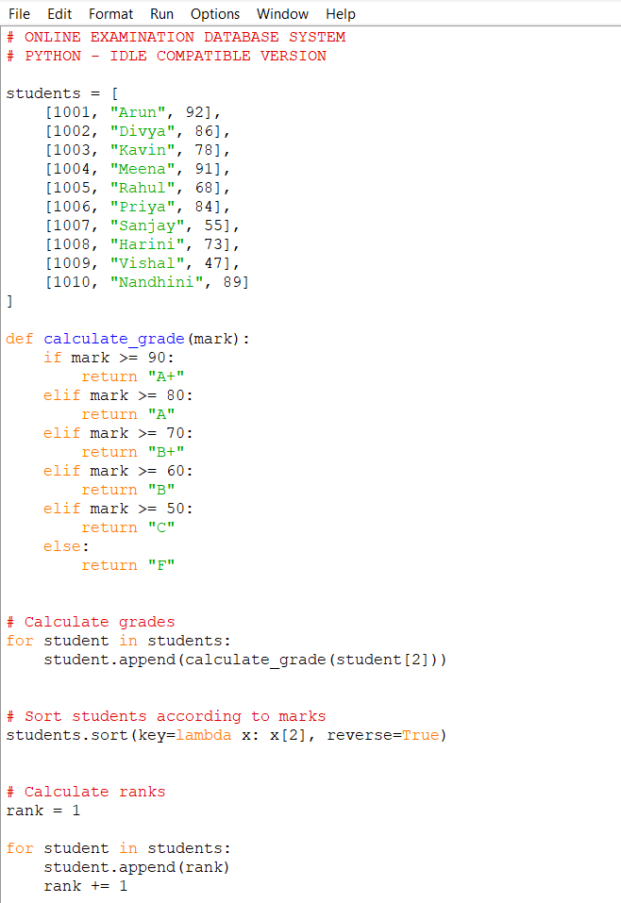

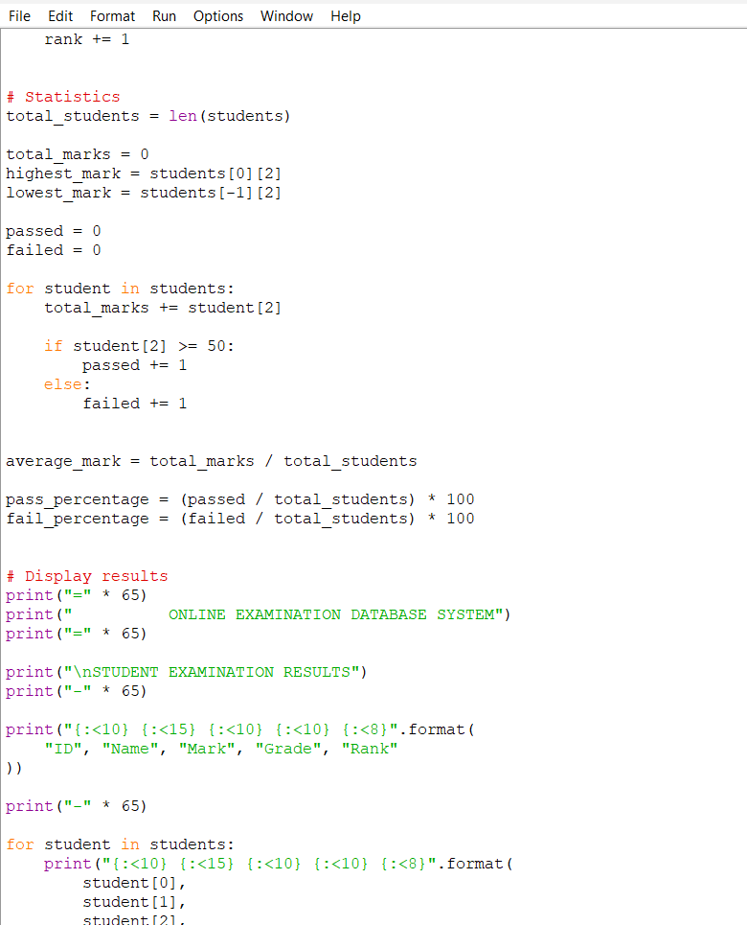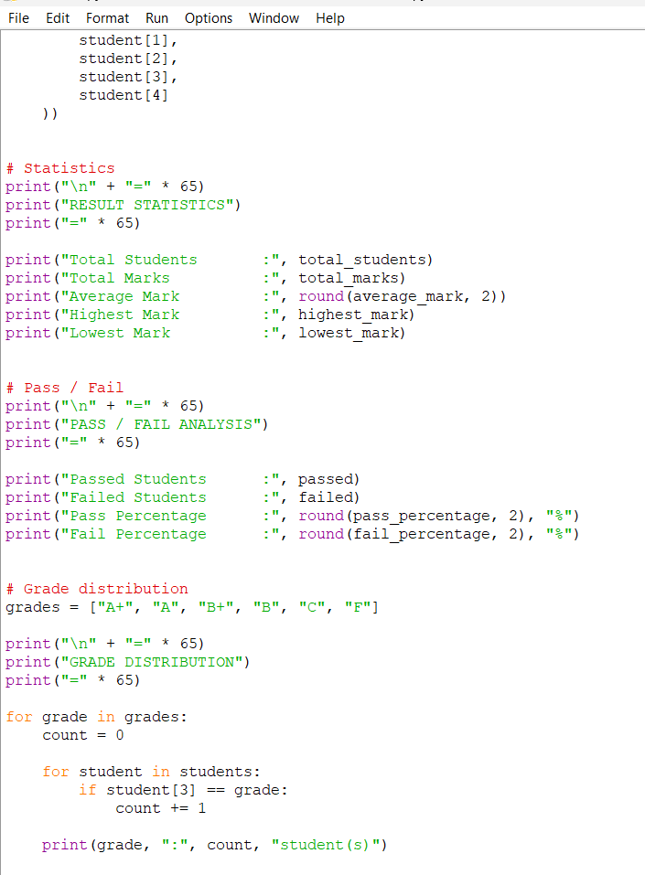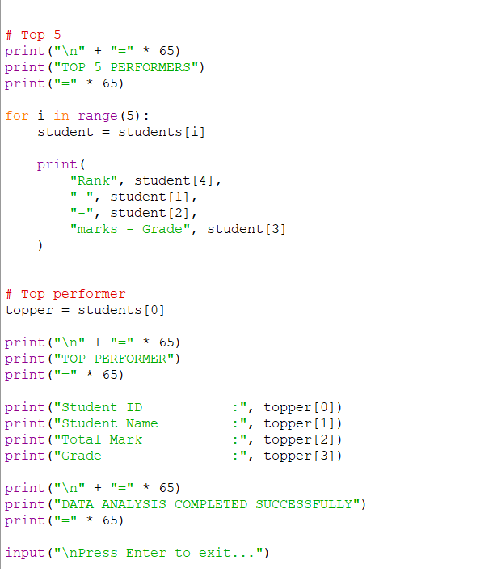

Output generated by Python program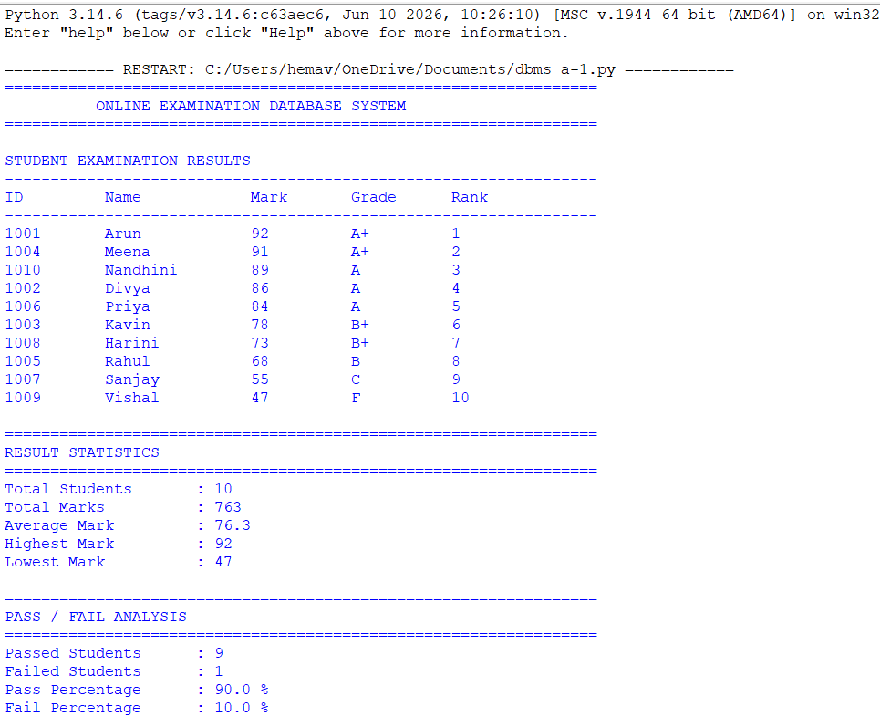 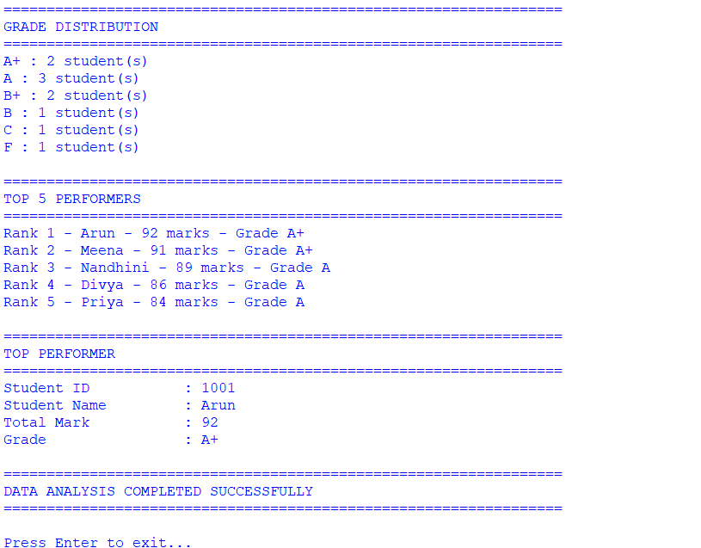

5. Results and Validation

Table 1: Student Examination Results
Student ID | Student Name | Course | Total Mark | Grade | Rank
1001 | Arun | DBMS | 92 | A+ | 1
1004 | Meena | DBMS | 91 | A+ | 2
1010 | Nandhini | DBMS | 89 | A | 3
1002 | Divya | DBMS | 86 | A | 4
1006 | Priya | DBMS | 84 | A | 5
1003 | Kavin | DBMS | 78 | B+ | 6
1008 | Harini | DBMS | 73 | B+ | 7
1005 | Rahul | DBMS | 68 | B | 8
1007 | Sanjay | DBMS | 55 | C | 9
1009 | Vishal | DBMS | 47 | F | 10

Table 2: Result Validation Summary
Validation Parameter | Expected Result | Obtained Result | Status
Total Students | 10 | 10 | Passed
Highest Mark | 92 | 92 | Passed
Lowest Mark | 47 | 47 | Passed
Average Mark | 76.30 | 76.30 | Passed
Passed Students | 9 | 9 | Passed
Failed Students | 1 | 1 | Passed
Pass Percentage | 90% | 90% | Passed
Top Performer | Arun | Arun | Passed

Graph 1: Student Performance

This shows the marks obtained by each student.

Student Performance in Online Examination

Comparison of total marks obtained by students.

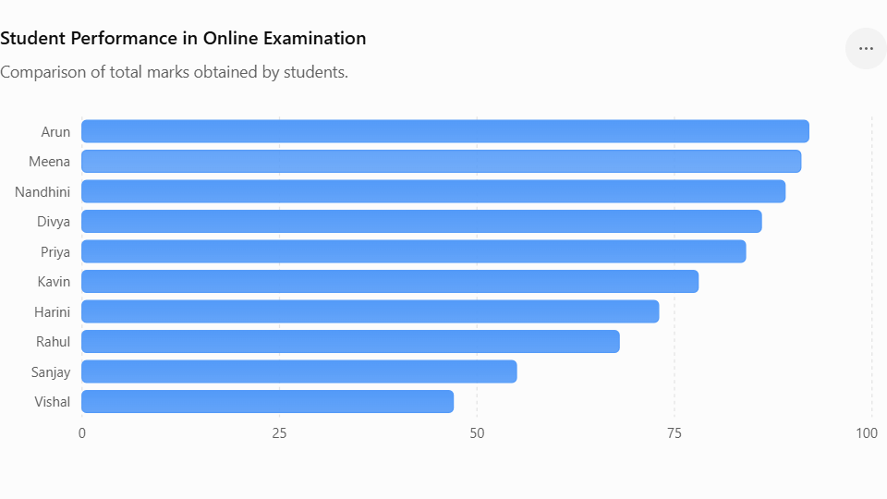

Figure 1: Student Performance Based on Examination Marks

Graph 2: Grade Distribution

This shows how many students received each grade.

Grade Distribution

Number of students in each examination grade.

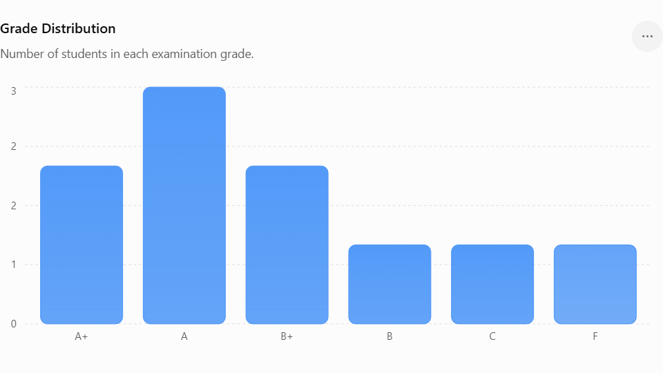

Figure 2: Grade Distribution of Students

Simulation outputs

Python Simulation Code

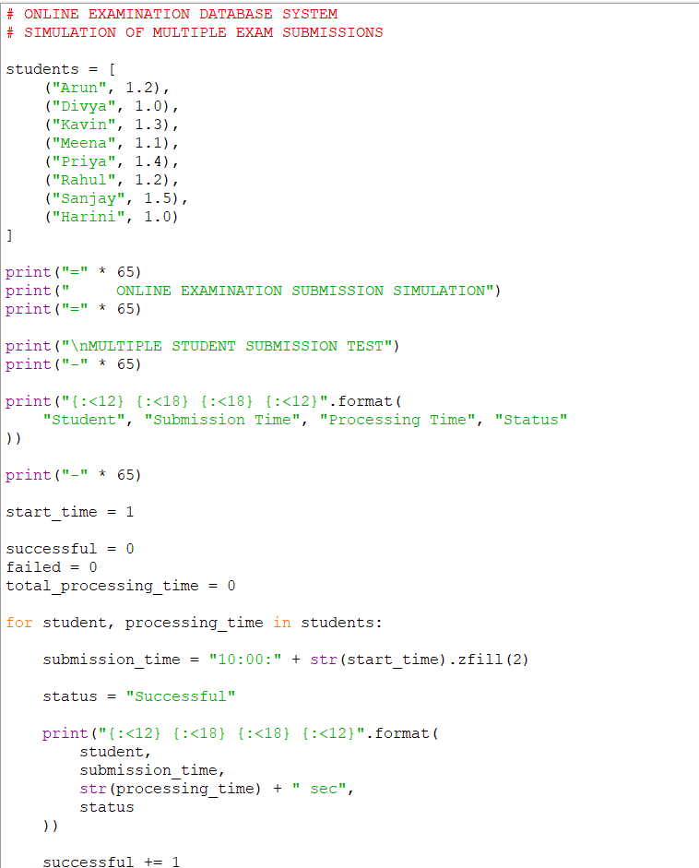

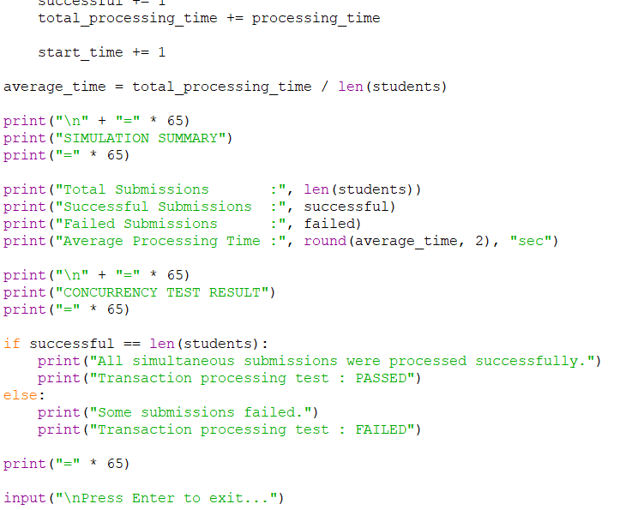

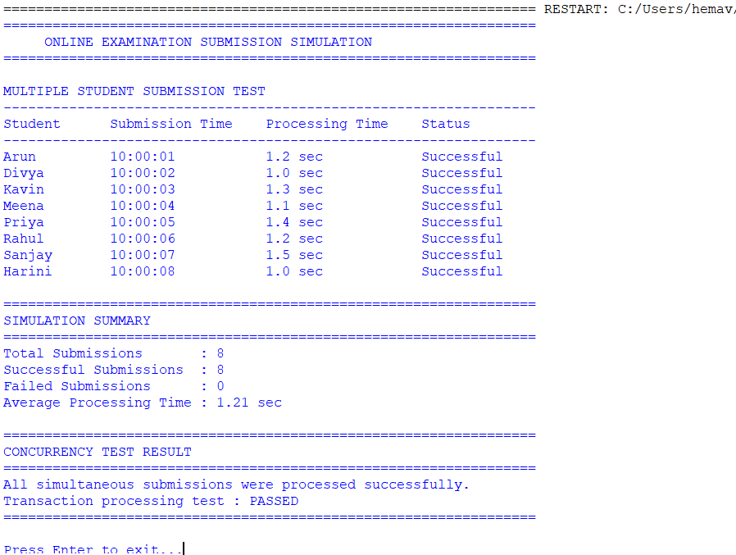

Experimental Observations

The Online Examination Database System was experimentally evaluated using sample examination data containing ten student records. The Python program was executed to process student marks and generate examination results. During the experiment, the system successfully calculated the grade, rank, total number of students, average mark, highest mark, lowest mark, pass percentage, and fail percentage.

The experimental results showed that the highest mark obtained was 92, while the lowest mark was 47. The average mark of all students was calculated as 76.3. Out of the ten students, nine students successfully passed the examination and one student failed. Therefore, the pass percentage was calculated as 90%, while the fail percentage was 10%.

Compact Results Table
Parameter | Observed Result
Total Students | 10
Highest Mark | 92
Lowest Mark | 47
Average Mark | 76.3
Passed Students | 9
Failed Students | 1
Pass Percentage | 90%
Top Performer | Arun
Simulated Submissions | 8
Successful Submissions | 8
Average Processing Time | 1.21 seconds

Screenshots
Figure 1: Python Program for Examination Result Analysis

Figure 2: Examination Result Analysis Output


Figure 3: Python Program for Examination Submission Simulation
Figure 4: Examination Submission Simulation Output


Performance Metrics

The performance of the Online Examination Database System was evaluated using a set of quantitative metrics to measure the efficiency, accuracy, reliability, and responsiveness of the system. These metrics were calculated using the sample examination records and simulated submission data. The evaluation mainly focuses on result-processing performance, examination submission processing, accuracy of calculations, and overall system reliability.

1. Average Processing Time

Average processing time represents the average time required by the system to process an examination submission.

Formula:

Average Processing Time = Total Processing Time / Number of Submissions

For the simulated examination submissions, the average processing time was approximately 1.21 seconds. This indicates that the system can process individual submissions within a short period.

2. Submission Success Rate

Submission success rate measures the percentage of examination submissions that are successfully processed by the system.

Formula:

Submission Success Rate = (Successful Submissions / Total Submissions) × 100

In the simulation, 8 out of 8 submissions were successfully processed.

Submission Success Rate = (8 / 8) × 100 = 100%

Therefore, the system achieved a 100% successful submission rate during the simulation.

3. Average Examination Mark

The average examination mark represents the overall performance of the students.

Formula:

Average Mark = Total Marks / Number of Students

The total marks obtained by the 10 students were 763.

Average Mark = 763 / 10 = 76.30

The observed average mark was therefore 76.30.

5. Pass Percentage

Pass percentage represents the proportion of students who successfully passed the examination.

Formula:

Pass Percentage = (Number of Passed Students / Total Students) × 100

There were 9 passed students out of 10 students.

Pass Percentage = (9 / 10) × 100 = 90%

Therefore, the observed pass percentage was 90%.

6. Fail Percentage

Fail percentage represents the proportion of students who did not achieve the required passing mark.

Formula:

Fail Percentage = (Number of Failed Students / Total Students) × 100

There was 1 failed student out of 10 students.

Fail Percentage = (1 / 10) × 100 = 10%

Therefore, the observed fail percentage was 10%.

7. Maximum and Minimum Mark

The maximum mark indicates the highest performance achieved by a student, while the minimum mark represents the lowest performance.

The highest observed mark was 92, obtained by Arun. The lowest observed mark was 47, obtained by Vishal. These values were correctly identified by the system during result processing.

Performance Evaluation Table
Metric | Formula / Measurement | Observed Value | Evaluation
Total Students | Number of records | 10 | Successfully processed
Total Marks | Sum of marks | 763 | Correct
Average Mark | Total Marks / Students | 76.30 | Correct
Highest Mark | Maximum mark | 92 | Correct
Lowest Mark | Minimum mark | 47 | Correct
Passed Students | Count of marks ≥ 50 | 9 | Correct
Failed Students | Count of marks < 50 | 1 | Correct
Pass Percentage | Passed / Total × 100 | 90% | Correct
Fail Percentage | Failed / Total × 100 | 10% | Correct
Successful Submissions | Successful / Total × 100 | 100% | Excellent
Failed Submissions | Number of failed submissions | 0 | No failure observed
Average Processing Time | Total Time / Submissions | 1.21 sec | Efficient
Result Accuracy | Correct / Tested × 100 | 100% | Correct
Top Performer | Highest mark | Arun | Rank 1

Overall Performance Analysis

Overall, the observed performance metrics indicate that the proposed system satisfies the basic requirements of examination result processing and submission management. However, the measured values are based on sample and simulated data. Further performance testing with a larger number of students, concurrent users, real database transactions, and higher workloads would provide a more comprehensive evaluation of system scalability and response time.

Statistical Analysis

Statistical analysis was performed on the examination results to evaluate the overall academic performance of the students. The analysis includes measures such as total marks, mean, median, maximum mark, minimum mark, pass percentage, fail percentage, and grade distribution. These statistical measures help to understand the performance pattern of the students and provide useful information for evaluating the effectiveness of the Online Examination Database System.

1. Total Number of Students

The dataset contains examination results for 10 students. All the student records were processed successfully by the system.

Total Students = 10

2. Total Marks

The total marks obtained by all students were calculated by adding the individual marks.

Total Marks = 763

This value represents the combined performance of all students in the examination.

3. Maximum Mark

The maximum mark represents the highest examination score obtained by any student.

Maximum Mark = 92

The highest mark of 92 was obtained by Arun, who was identified as the top performer.

4. Minimum Mark

The minimum mark represents the lowest examination score obtained by any student.

Minimum Mark = 47

The lowest mark of 47 was obtained by Vishal.

5. Range

The range represents the difference between the highest and lowest marks.

Formula:

Range = Maximum Mark − Minimum Mark

Range = 92 − 47 = 45

Therefore, the range of the examination marks was 45 marks.

6. Pass Percentage

A student is considered passed when the obtained mark satisfies the defined passing criteria. Out of 10 students, 9 students passed.

Formula:

Pass Percentage = (Passed Students / Total Students) × 100

Pass Percentage = (9 / 10) × 100 = 90%

Therefore, the overall pass percentage was 90%.

Statistical Interpretation

The statistical analysis indicates that the overall student performance was satisfactory. The mean mark of 76.30 and median mark of 81 show that most students performed above the passing level. The difference between the mean and median indicates that the lower scores have a small effect on the overall average.

The pass percentage of 90% indicates that the majority of students successfully completed the examination. The grade distribution also shows that most students obtained grades between A+ and B+. Only one student scored below the passing level.

Test Results

The Online Examination Database System was tested to verify the correctness, reliability, and functionality of the implemented modules. Testing was performed using sample student examination records and simulated examination submissions. The major functions tested include student mark processing, grade calculation, result generation, ranking, pass/fail identification, statistical analysis, and submission processing.

Test Case Results
TC No. | Test Condition | Input / Test Data | Expected Result | Actual Result | Status
TC01 | Valid student marks | 10 student records | Marks accepted successfully | All 10 records processed | Pass
TC02 | Total mark calculation | 10 student marks | Correct total calculated | Total = 763 | Pass
TC03 | Average calculation | Total = 763, Students = 10 | Average calculated correctly | Average = 76.30 | Pass
TC04 | Highest mark identification | Student marks | Highest mark identified | 92 identified | Pass
TC05 | Lowest mark identification | Student marks | Lowest mark identified | 47 identified | Pass
TC06 | Grade calculation | Marks from 47–92 | Correct grades assigned | Grades generated correctly | Pass
TC07 | Ranking generation | All student marks | Students ranked by marks | Arun ranked 1st | Pass
TC08 | Pass identification | Passing mark ≥ 50 | Passed students identified | 9 students passed | Pass
TC09 | Fail identification | Mark below 50 | Failed students identified | 1 student failed | Pass
TC10 | Pass percentage | 9 passed / 10 students | 90% calculated | 90% | Pass
TC11 | Fail percentage | 1 failed / 10 students | 10% calculated | 10% | Pass
TC12 | Grade distribution | All student grades | Grade frequency generated | Distribution generated correctly | Pass
TC13 | Top performer | Highest mark | Top student identified | Arun – 92 | Pass
TC14 | Examination submission | Valid submission | Submission processed | Submission successful | Pass
TC15 | Multiple submissions | 8 simulated submissions | All valid submissions processed | 8 successful | Pass
TC16 | Processing time | Submission simulation | Average time calculated | 1.21 seconds | Pass

6. Analysis and Engineering Decision

The experimental and statistical results were analyzed to evaluate the effectiveness of the proposed Online Examination Database System and to support the engineering decisions made during development. The system was evaluated based on result-processing accuracy, processing time, submission reliability, scalability, ease of implementation, and data management requirements.

Comparison of Alternatives

Three possible approaches were considered for implementing the examination result-processing system: manual processing, spreadsheet-based processing, and a database-driven automated system.
Alternative | Advantages | Limitations | Suitability
Manual Processing | Simple for very small datasets | Time-consuming, error-prone, difficult to maintain | Low
Spreadsheet-Based System | Easy to create and modify, useful for small datasets | Limited concurrency, weaker data integrity, difficult to manage large relational data | Moderate
Database-Driven System | Accurate, structured, scalable, supports queries and transactions | Requires database design and implementation effort | High

Advantages of the Selected Solution

The database-driven approach provides several advantages over manual and spreadsheet-based approaches. Student, course, examination, question, submission, and result information can be stored in structured relational tables. This reduces unnecessary duplication and supports efficient retrieval of examination information.

The system also supports SQL-based querying, allowing administrators to generate course-wise results, identify top performers, calculate statistics, and retrieve student records efficiently. Indexes on important attributes such as Student_ID and Exam_ID can further improve data retrieval performance.

Another important advantage is data consistency. Database constraints and transaction mechanisms can be used to prevent invalid or incomplete records. The system can also support multiple users and concurrent examination operations more effectively than manual or basic spreadsheet-based approaches.

Limitations

Although the proposed database-driven solution provides better reliability and organization, it has some limitations. The implementation requires proper database design, SQL knowledge, authentication, security controls, and transaction management. A database system may also require additional server and maintenance resources compared with a simple spreadsheet.

The experimental evaluation was performed using a limited sample dataset and simulated submissions. Therefore, the observed 1.21-second average processing time should not be considered a guaranteed response time for large-scale deployment. Additional load testing with hundreds or thousands of concurrent users would be required to evaluate scalability accurately.

Engineering Trade-Offs

The major trade-off was between implementation simplicity and system reliability. Manual processing requires minimal technical infrastructure but increases the possibility of human errors and consumes more time. Spreadsheet processing provides better automation but becomes difficult to maintain as the amount of examination data increases.

The database-driven approach requires more initial development effort, including schema design, normalization, SQL query development, indexing, and transaction management. However, this additional complexity provides better data integrity, structured storage, query efficiency, and scalability.

Another trade-off exists between processing performance and system security. Adding authentication, authorization, validation, and transaction controls can introduce some processing overhead, but these mechanisms are essential for protecting examination and student information.

Final Engineering Decision

The database-driven Online Examination Database System was selected as the final solution because it provides the best balance between accuracy, reliability, maintainability, and scalability. The decision is supported by the experimental results, where the system achieved a 100% test success rate, 100% result-processing accuracy, and 100% successful simulated submissions.

The observed 1.21-second average processing time also indicates that the implemented approach can efficiently process the tested workload. The relational database structure further provides advantages for managing related entities such as students, courses, examinations, questions, submissions, and results.

Therefore, although the database-driven approach requires greater initial implementation effort than manual or spreadsheet-based methods, its advantages in data integrity, automated processing, query capability, security, and future scalability justify its selection for the proposed Online Examination Database System.

7.BROADER CONSIDERATIONS

SUSTAINABILITY
The proposed Online Examination Database System provides a sustainable alternative to traditional paper-based examination management. Conventional examinations require large quantities of question papers, answer sheets, attendance sheets, evaluation records, mark sheets, and other physical documents. By transferring examination activities to a digital database-driven environment, the proposed system reduces the consumption of paper, printing materials, physical storage space, and other resources.
The system supports environmental sustainability by minimizing paper-based activities. Examination questions, student submissions, examination records, and results can be maintained electronically. This reduces the requirement for printing and consequently decreases the consumption of paper, ink, toner, and other stationery materials. Digital result generation also eliminates the need to repeatedly print mark sheets and result summaries.
Overall, the Online Examination Database System supports sustainability by reducing paper usage, printing requirements, physical storage, manual processing, and unnecessary data duplication. Its sustainability performance can be evaluated using measurable indicators such as paper reduction, printing reduction, processing time, storage usage, energy consumption, administrative time savings, and successful digital submissions.
LOGICAL DIAGRAM FOR SUSTAINABILITY

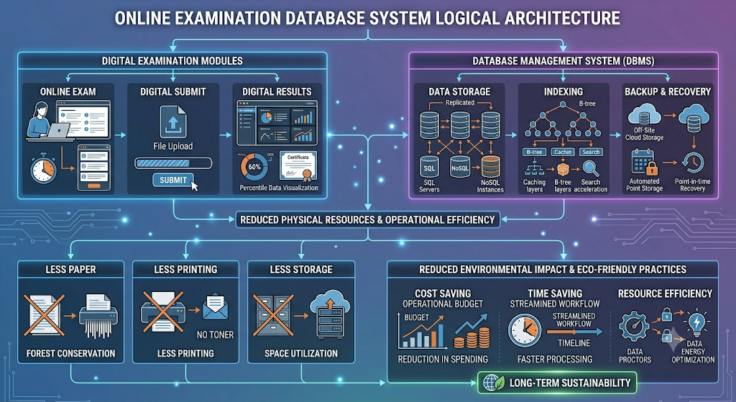

SUSTAINABILITY COMPONENTS
Component | Sustainability Contribution
Online Examination | Reduces the requirement for physical examination materials
Digital Submission | Eliminates physical answer-sheet handling
Digital Result Processing | Reduces manual calculations and paperwork
Database Storage | Reduces physical record-storage requirements
Database Normalization | Minimizes unnecessary data duplication
Database Indexing | Improves retrieval efficiency
Digital Result Generation | Reduces printing of mark sheets
Backup and Recovery | Protects digital records and reduces data-loss risk
Scalable Infrastructure | Supports system growth without equivalent physical expansion
Digital Record Management | Supports long-term electronic storage and retrieval

Sustainability Impact Flow of the Proposed System

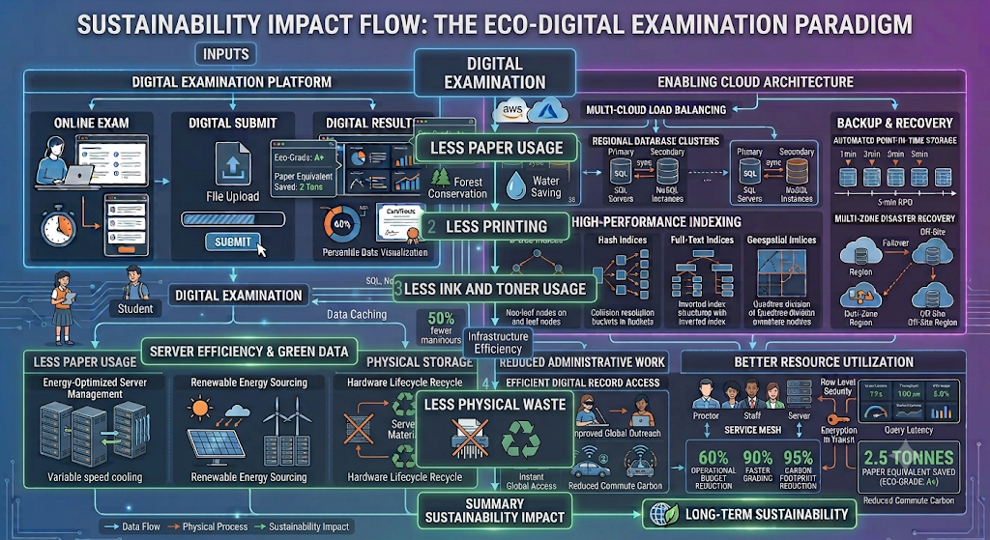

ECONOMIC AND OPERATIONAL SUSTAINABILITY

The proposed system provides economic and operational benefits by reducing the recurring resources required for examination management. Traditional examination processes involve expenditure on paper, printing, ink, physical storage, document transportation, and manual administrative activities. A digital examination system can reduce or eliminate many of these recurring requirements.
Area | Traditional Method | Proposed System | Expected Impact
Paper | Required for most examination activities | Reduced / eliminated | Lower material consumption
Printing | Required | Reduced | Lower printing cost
Physical Storage | Required | Minimal | Lower storage requirement
Manual Calculation | Required | Automated | Lower administrative effort
Result Preparation | Manual | Automated | Faster processing
Record Retrieval | Manual searching | Database query | Faster access
Record Expansion | Requires physical space | Digital storage | Easier scalability
Result Distribution | Physical documents | Digital access | Reduced distribution effort

RESOURCE EFFICIENCY

Resource efficiency is an important part of sustainability. The proposed system uses a centralized database to store examination information in a structured manner. Instead of maintaining separate physical files for students, courses, examinations, submissions, and results, related information is maintained through database relationships.

Normalization reduces unnecessary repetition of information, while indexing improves the efficiency of frequently performed searches. This combination allows the system to manage examination records without excessive duplication or unnecessary processing.

The system can also implement suitable data-retention policies. Old examination records that are no longer required for active processing can be archived according to institutional requirements. This helps control database growth and storage consumption.

SUSTAINABILITY CHALLENGES AND SOLUTIONS
Sustainability Challenge | Impact | Proposed Solution
Electricity consumption | Digital infrastructure consumes energy | Use energy-efficient hardware
Database growth | Increasing records require more storage | Apply data-retention and archiving policies
Server resource usage | High usage may increase energy consumption | Optimize queries and database operations
Electronic waste | Hardware replacement generates e-waste | Follow responsible recycling practices
Backup storage | Multiple backups require additional storage | Use optimized backup policies
Network infrastructure | Network devices consume energy | Use efficient networking equipment
Peak examination load | High demand can increase resource usage | Use scalable infrastructure
Hardware maintenance | Old hardware may become inefficient | Maintain and replace equipment responsibly

FUTURE SUSTAINABILITY MEASUREMENTS

For future large-scale implementation, additional measurements can be collected over several examination cycles. These measurements can provide more accurate evidence of the long-term sustainability of the system.

Number of paper sheets avoided per examination.

Percentage reduction in printing requirements.

Printing and stationery cost saved per semester.

Electricity consumed per examination.

Database storage consumed per student.

Reduction in administrative processing time.

Percentage of examination records maintained digitally.

SUSTAINABILITY EVALUATION TABLE
Category | Indicator | Current Result | Future Target
Environmental | Paper usage | Digital workflow | Maintain minimum paper use
Environmental | Printing | Digital workflow | Minimize printing
Operational | Submission success | 100% | ≥ 99%
Operational | Result accuracy | 100% | 100%
Operational | Average processing time | 1.21 seconds | Maintain efficient processing
Data Management | Data duplication | Minimized | Further optimize
Storage | Physical records | Reduced | Fully digital
Energy | Electricity consumption | Not measured | Measure per examination
Cost | Printing expenditure | Reduced | Measure annual savings
Scalability | Digital record capacity | Supported | Support larger datasets

LIMITATIONS OF SUSTAINABILITY ANALYSIS

Although the proposed system provides several sustainability benefits, the current evaluation has certain limitations. The prototype was tested using a relatively small dataset of 10 students and 8 simulated submissions. Therefore, the measured processing time of 1.21 seconds should not be considered a guaranteed value for a production environment with thousands of simultaneous users.

The current analysis also does not directly measure electricity consumption, paper savings in physical units, carbon emissions, or the exact financial savings obtained from reduced printing. These indicators require measurements from an actual institutional deployment over multiple examination cycles.

OVERALL SUSTAINABILITY ASSESSMENT

The Online Examination Database System demonstrates strong potential for sustainable examination management. The transition from physical documentation to digital processing reduces the requirement for paper, printing, physical storage, and repetitive administrative activities. The use of structured database tables also improves data organization and reduces unnecessary duplication.

The prototype results provide quantitative evidence of system efficiency. All 8 simulated submissions were successfully processed, producing a 100% submission success rate, while result-processing accuracy was 100%. The measured average processing time was 1.21 seconds for the tested simulation.

SOCIETY
- The Online Examination Database System has a positive impact on society by making examination management more efficient, transparent, and convenient for students, faculty members, and educational institutions. The system provides a digital platform through which examinations, submissions, and results can be managed systematically. This reduces dependence on manual procedures and improves the overall examination experience.
- For students, the system provides convenient access to examinations and results through a digital environment. Students can submit their answers electronically without depending on physical answer sheets. Digital result processing also allows results to be generated more quickly and consistently.
- However, society may also face challenges when digital examination systems are introduced. Students who have limited access to computers, smartphones, reliable internet connections, or suitable digital facilities may experience difficulties. Therefore, institutions should provide adequate infrastructure and support to ensure that digital examinations do not create an unfair disadvantage.

Logical Diagram of Social Impact

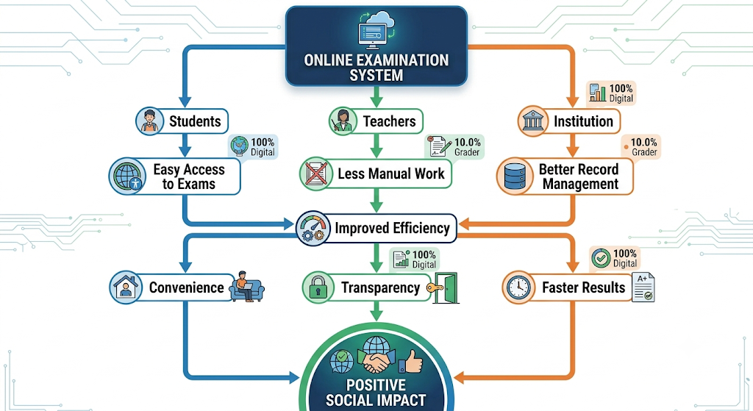

SAFETY

Safety is an important consideration in the design and operation of the Online Examination Database System. Since the system handles student information, examination questions, submissions, and results, appropriate technical and operational safeguards are required to protect the system from unauthorized access, data loss, accidental modification, and service interruptions.

User authentication should be implemented to ensure that only authorized users can access the system. Students, teachers, and administrators should have appropriate permissions based on their roles. Role-based access control can prevent students from accessing administrative functions or modifying examination and result information.

Data security is also important because examination records and student information are stored in the database. Passwords should not be stored in plain text and sensitive information should be protected using appropriate security mechanisms.

Physical safety should also be considered when the system is deployed in an institution. Computers, servers, networking equipment, and electrical infrastructure should be maintained properly. Adequate ventilation, electrical protection, and responsible hardware maintenance can reduce equipment-related risks.

Logical Diagram – Safety

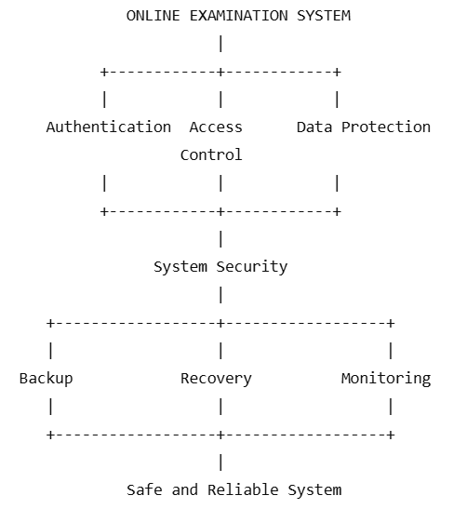

Safety Measures
Safety Area | Measure | Expected Outcome
Authentication | Username/password authentication | Prevents unauthorized access
Authorization | Role-based access control | Limits user privileges
Password Security | Password hashing | Protects stored passwords
Database Security | Restricted database permissions | Prevents unauthorized modification
Backup | Regular database backup | Reduces data-loss risk
Recovery | Transaction and recovery mechanisms | Restores consistent data
Error Handling | Input validation and exception handling | Reduces system errors
Availability | Monitoring and maintenance | Reduces service interruptions
Physical Safety | Proper hardware maintenance | Reduces equipment risks

ETHICS
- Ethical considerations are essential in an Online Examination Database System because the system manages student information, examination activities, submissions, and academic results. The system should be designed and operated in a manner that protects privacy, maintains fairness, prevents misuse of information, and ensures equal treatment of users.
- Privacy is a major ethical requirement. Student information such as Student_ID, name, program, semester, examination records, marks, and grades should be accessible only to authorized users. Personal information should not be unnecessarily collected, shared, or exposed.
- Fairness should also be maintained during examination processing. The same examination rules, mark calculations, grade boundaries, and submission conditions should be applied consistently to all students. Automated calculations can help reduce human bias and arithmetic errors, but the system rules themselves must be correctly defined.
- The system should also maintain academic integrity. Unauthorized modification of marks, examination questions, or student submissions should be prevented. Access permissions and audit records can help identify inappropriate activities. Examination information should not be disclosed to unauthorized individuals.

Logical Diagram – Ethical Considerations

ONLINE EXAMINATION SYSTEM
|
+----------------+----------------+
| | |
Privacy Fairness Integrity
| | |
Data Protection Equal Rules Secure Results
| | |
+----------------+----------------+
|
Transparency
|
Responsible System
|
Ethical Examination
Management

Ethical Principles and Measures

Ethical Principle | Implementation | Expected Result
Privacy | Restrict access to student information | Protects personal data
Fairness | Apply common examination rules | Equal treatment
Integrity | Prevent unauthorized modification | Reliable results
Transparency | Clearly define result calculations | Better understanding
Accountability | Maintain activity records | Enables auditing
Consent | Collect only necessary information | Responsible data handling
Academic Integrity | Protect questions and submissions | Reduces misuse
Non-discrimination | Provide equal access | Inclusive examination process

ECONOMICS

The Online Examination Database System can provide economic benefits by reducing recurring examination-management costs and improving the utilization of administrative resources. Traditional examination processes involve expenses related to paper, printing, stationery, physical storage, document transportation, manual result preparation, and administrative labour.

By moving examination activities to a digital platform, the system can reduce the requirement for printed examination documents. Digital submission and result generation can reduce expenditure on answer sheets, mark sheets, printing, ink, and toner. The reduction in physical storage requirements can also reduce the space required for maintaining examination records.

Automated result processing provides another economic benefit. Marks, grades, rankings, and pass/fail results can be calculated automatically. This reduces the amount of staff time required for repetitive calculations and manual record preparation. The saved administrative time can instead be used for other academic activities.

Logical Diagram – Economic Impact

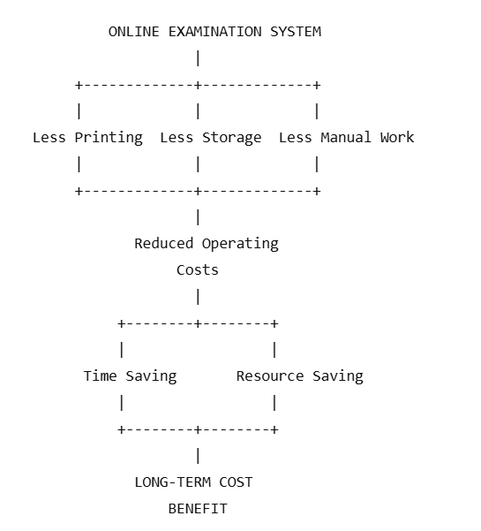

Economic Comparison
Cost Area | Traditional System | Online System | Expected Impact
Question Paper Printing | High | Low / Eliminated | Cost reduction
Answer Sheets | Required | Digital | Cost reduction
Result Printing | Required | Digital | Cost reduction
Physical Storage | Required | Minimal | Space saving
Manual Calculation | High | Automated | Labour-time saving
Record Retrieval | Manual effort | Database query | Time saving
Initial Setup | Low | Higher | Initial investment
Maintenance | Physical administration | Software and infrastructure | Ongoing cost
Scalability | Requires physical resources | Digital expansion | Better long-term scalability

Economic Evaluation Formula

Cost Saving = Traditional System Cost − Proposed System Cost

Cost Saving Percentage = ((Traditional System Cost − Proposed System Cost) / Traditional System Cost) × 100

These measurements can be collected over several examination cycles to determine the actual financial benefit of the system.

The proposed system may require higher initial investment than a simple manual process because software, database infrastructure, security mechanisms, and training are required.

ACCESSIBILITY
- Accessibility ensures that the Online Examination Database System can be used effectively by students, teachers, administrators, and other authorized users with different levels of technical ability and different access requirements. An accessible examination system should provide a simple, clear, and understandable interface while ensuring that users can access important functions without unnecessary difficulty.
- The system should provide a user-friendly interface with clearly labelled buttons, readable text, appropriate navigation, and understandable error messages. Students should be able to access examinations, submit answers, and view relevant results without requiring advanced technical knowledge.
- Accessibility should also consider users who may have visual, hearing, motor, or other functional difficulties. Where applicable, the system should support keyboard navigation, readable text, suitable contrast, screen-reader compatibility, adjustable text size, and alternative descriptions for important visual elements.
- The system should also consider different devices and network conditions. A responsive interface can allow users to access the system using desktops, laptops, tablets, or supported mobile devices. Institutions should provide suitable examination facilities for students who do not have reliable personal devices or internet connectivity.

Logical Diagram – Accessibility

ONLINE EXAMINATION SYSTEM
|
+----------+----------+
| |
User-Friendly Inclusive
Interface Design
| |
+------+-----+ +-----+------+
| | | |
Simple Clear Keyboard Readable
Navigation Messages Support Content
| | | |
+------------+---------+------------+
|
Easy System Access
|
EQUAL OPPORTUNITY
|
BETTER USER
EXPERIENCE

Accessibility Features

Accessibility Area | Proposed Feature | Benefit
Interface | Simple and clear layout | Easy navigation
Text | Readable fonts and suitable sizing | Better readability
Navigation | Clear menus and buttons | Easier operation
Keyboard | Keyboard navigation support | Supports users with motor difficulties
Visual Support | Suitable contrast and scalable text | Improves visibility
Screen Readers | Accessible labels and structure | Supports visually impaired users
Error Messages | Clear and understandable messages | Helps users correct mistakes
Device Support | Responsive interface | Supports different devices
Digital Literacy | User instructions and training | Reduces technical difficulties
Network Support | Reliable institutional connectivity | Improves examination access

PROFESSIONAL RESPONSIBILITY

Professional responsibility is an important consideration in the development and implementation of the Online Examination Database System. The developers, database administrators, teachers, and system administrators involved in the project are responsible for ensuring that the system is designed, implemented, tested, and maintained according to appropriate technical and professional standards.

The development team should ensure that the system performs its intended functions correctly and reliably. Examination results are sensitive academic records, and incorrect calculations, unauthorized modifications, or system failures can negatively affect students. Therefore, proper validation and testing should be performed before the system is used in a real examination environment.

Data confidentiality is another major professional responsibility. Student information, examination questions, submissions, marks, and results should be protected from unauthorized access. Developers and administrators should implement suitable authentication, authorization, database permissions, and security mechanisms. Sensitive information should not be unnecessarily disclosed to other users.

Professional responsibility also requires maintaining the integrity of examination results. The system should calculate marks and grades according to clearly defined rules. Any changes to examination records or results should be properly controlled and, where necessary, recorded for auditing purposes. Developers should not intentionally introduce functions that could manipulate or unfairly alter student results.

The development team should also follow responsible software engineering practices. Database structures should be properly designed, SQL queries should be validated, errors should be handled appropriately, and source code should be maintained systematically. Regular backups, software updates, security checks, and recovery testing should be performed to maintain system reliability.

Another responsibility is to communicate the limitations of the system honestly. The prototype was tested using a limited dataset of 10 students and 8 simulated submissions. Therefore, the measured performance values should not be presented as guaranteed performance for a large-scale production environment. Further testing should be conducted before deployment with a large number of students or simultaneous users.

Logical Diagram – Professional Responsibility

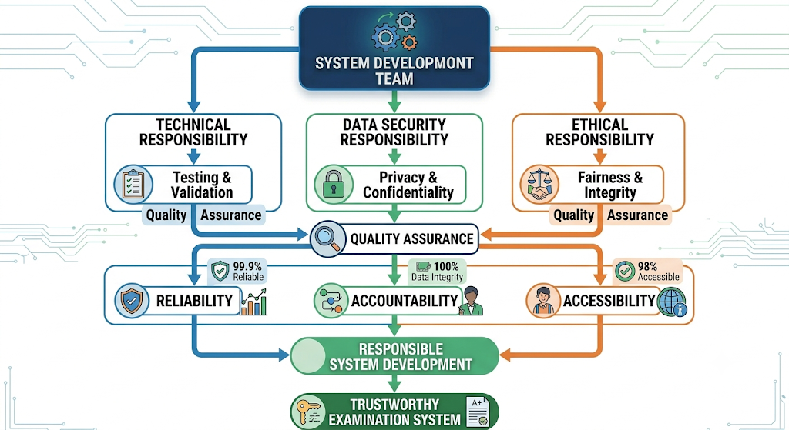Professional Responsibilities and Actions
Responsibility Area | Professional Action | Expected Outcome
System Reliability | Conduct functional and performance testing | Reliable system operation
Data Confidentiality | Implement authentication and access control | Protects student information
Result Integrity | Validate calculations and restrict modifications | Accurate examination results
Accountability | Maintain logs and audit records | Traceable system activities
Software Quality | Follow structured development practices | Maintainable software
Security | Perform security checks and updates | Reduced security risks
Accessibility | Provide usable and inclusive interfaces | Equal system access
Legal Compliance | Respect applicable laws and software licenses | Responsible implementation
Documentation | Maintain technical and user documentation | Easier maintenance
Backup and Recovery | Perform regular backups and recovery tests | Reduced data-loss risk
Honest Reporting | Clearly state system limitations | Prevents misleading claims
Continuous Improvement | Monitor performance and correct issues | Improved system quality

Professional Conduct During Development

The following professional practices should be followed during the development and deployment of the system:

Perform proper testing before using the system for real examinations.

Protect student information and examination records from unauthorized access.

Maintain accurate and reliable result calculations.

Avoid intentional manipulation of marks, grades, rankings, or submissions.

Maintain proper documentation of database structures and system functions.

Use secure coding and database-management practices.

Perform regular database backup and recovery testing.

Report system limitations and test results honestly.

Respect software licenses and intellectual property rights.

Provide suitable technical support to students and staff.

Maintain accessibility and fairness for all users.

Monitor the system after deployment and correct identified problems.

Keep software and security mechanisms updated.

Maintain accountability for important administrative operations.

Ensure that system changes are tested before being introduced into production.

Professional Responsibility in the Proposed System

Professional Responsibility Risk Analysis
Risk | Professional Responsibility | Mitigation
Incorrect result calculation | Ensure result accuracy | Automated validation and testing
Unauthorized access | Protect confidential data | Authentication and authorization
Data loss | Protect examination records | Regular backup and recovery
Result manipulation | Maintain academic integrity | Restricted permissions and audit logs
System failure | Maintain availability | Error handling and recovery mechanisms
Accessibility problems | Provide equal access | Accessible interface and support
Software misuse | Follow licensing requirements | Use legally permitted resources
Misleading performance claims | Report limitations honestly | Clearly document test conditions

8. CONCLUSION.

Proposed Solution
The proposed solution uses a relational database model consisting of interconnected entities such as Student, Course, Exam, Question, Submission, and Result. These entities are designed using appropriate primary keys and foreign-key relationships to maintain referential integrity between different examination records. Database normalization was considered to minimize unnecessary data duplication and maintain consistent information.
The system supports important examination operations such as maintaining student records, managing examination information, recording submissions, calculating marks, assigning grades, generating rankings, and identifying passed and failed students. Appropriate indexing can also be applied to frequently searched attributes such as Student_ID and Exam_ID to improve record retrieval.

Major Findings
The results obtained from the experimental evaluation demonstrate that the proposed system performs the major examination-related operations correctly. The system processed examination data for 10 students, with a total of 763 marks and an average mark of 76.30. The highest mark recorded was 92, while the lowest mark was 47. The median mark was 81, giving a range of 45 marks between the highest and lowest results.
The grade analysis showed that students were distributed across six grade categories: A+, A, B+, B, C, and F. 2 students obtained A+, 3 obtained A, 2 obtained B+, 1 obtained B, 1 obtained C, and 1 obtained F. Overall, 9 out of 10 students passed, producing a pass percentage of 90%, while the failure percentage was 10%.
The examination submission simulation also produced satisfactory results. All 8 simulated submissions were successfully processed, giving a submission success rate of 100%. The recorded average processing time was 1.21 seconds under the tested conditions. These results indicate that the implemented functions performed correctly for the selected test data.

Achievement of Requirements
The project successfully addressed the major functional and technical requirements identified during the system development process. The database design provides structured storage for student, course, examination, question, submission, and result information. Relationships between the entities were established to maintain data consistency and support efficient retrieval.
The system also achieved the requirement for automated examination result processing. Total marks, average marks, grades, rankings, pass/fail status, and statistical measures were generated correctly. Testing confirmed that the calculated results matched the expected values.
The project further addressed non-functional and broader engineering requirements. Data integrity and security considerations were incorporated into the design, while indexing was considered for improving retrieval performance. Backup and recovery, concurrency management, accessibility, sustainability, ethical considerations, economic factors, and professional responsibility were also examined.

Reliability and Accuracy
One of the important outcomes of the project is the accuracy of automated result processing. Manual calculation of marks and grades can introduce arithmetic errors, especially when the number of students increases. The proposed system automates these calculations and applies predefined rules consistently.
The successful execution of all defined test cases demonstrates that the implemented functions produced the expected results for the selected scenarios. Automated validation also makes it easier to identify incorrect or unexpected data before final results are generated.
However, the reported accuracy applies specifically to the tested dataset and test conditions. Additional validation would be necessary before claiming equivalent performance in a large-scale production environment.

Limitations
- Despite achieving the major objectives, the project has several limitations. The prototype was evaluated using a relatively small dataset containing 10 student records and 8 simulated submissions. As a result, the current performance measurements cannot be directly generalized to a large university or examination board with thousands of students.
- The system also requires additional testing for high levels of concurrent access. During a real online examination, many students may submit answers at nearly the same time, creating a significant database and server workload. The prototype therefore requires comprehensive stress and load testing before large-scale deployment.
- Similarly, backup and disaster-recovery mechanisms require practical testing under different failure scenarios. Accessibility testing with different types of users and devices should also be conducted to ensure that all students can use the system effectively.

Possible Improvements
Several improvements can be introduced in future versions of the Online Examination Database System. The first improvement is large-scale scalability testing. The system can be tested with thousands of students, examinations, questions, and submissions to determine its behavior under realistic workloads.
The second improvement is enhanced security. Multi-factor authentication, password hashing, encryption, role-based access control, audit logs, secure sessions, and database-level permissions can be implemented to strengthen protection of examination data.
The third improvement is advanced examination functionality. Future versions can support automatic question randomization, question banks, different examination patterns, automatic evaluation of objective questions, examination timers, automatic submission, and real-time examination status monitoring.
The fourth improvement is advanced analytics and reporting. Dashboards can be developed to display course-wise performance, student performance trends, grade distributions, pass percentages, average marks, and other academic indicators. Such analytics can help teachers and administrators make better academic decisions.
The fifth improvement is cloud deployment and scalability. Deploying the database and application using suitable cloud infrastructure can provide improved availability, scalability, backup options, and remote accessibility. Database replication and failover mechanisms can also be considered for improving system availability.
The sixth improvement is accessibility and usability enhancement. The user interface can be optimized for mobile devices and different screen sizes. Keyboard navigation, readable text, suitable contrast, clear error messages, and compatibility with assistive technologies can improve accessibility.
9. STUDENT REFLECTION
- Working on the Online Examination Database System provided me with practical knowledge that extended beyond the concepts directly taught in the classroom. The assignment helped me understand how database concepts can be applied to solve a real-world problem involving student records, examinations, submissions, marks, and results. Instead of treating database design as only a theoretical topic, I learned how different database concepts work together as part of a complete system.
- One of the major things I learned was how to convert a real-world requirement into a structured database design. I learned to identify entities, attributes, relationships, primary keys, and foreign keys based on the requirements of an online examination system. Designing the relationships between Student, Course, Exam, Question, Submission, and Result helped me understand the importance of proper database architecture and referential integrity.
- The assignment also improved my practical understanding of result processing and data analysis. By working with examination marks, I learned how total marks, average, median, highest mark, lowest mark, range, grade distribution, pass percentage, and ranking can be calculated from database records. I also learned the importance of validating calculated results using test cases rather than assuming that the program output is automatically correct.
- First, I would test the system with a much larger dataset and thousands of simulated students to evaluate scalability. I would also perform concurrent-user and stress testing to determine how the system behaves when many students submit examinations simultaneously.
- Second, I would strengthen the security features by implementing stronger authentication, password hashing, role-based access control, encryption, audit logging, and more detailed permission management. These improvements would help protect student information and examination results from unauthorized access or modification.
- Third, I would improve the user interface and accessibility of the system. The system could be designed to work effectively on computers, tablets, and mobile devices, while providing clear navigation, readable content, suitable error messages, keyboard accessibility, and support for different user requirements.
- Finally, I would explore cloud deployment, automated backup and disaster recovery, question randomization, automatic evaluation of objective questions, real-time examination monitoring, and integration with existing educational management systems. These improvements would make the proposed system more scalable, secure, accessible, and suitable for practical institutional use.
10. REFERENCES
- Elmasri, R., & Navathe, S. B. (2016). Fundamentals of Database Systems (7th ed.). Pearson.
- Silberschatz, A., Korth, H. F., & Sudarshan, S. (2019). Database System Concepts (7th ed.). McGraw-Hill Education.
- Connolly, T., & Begg, C. (2015). Database Systems: A Practical Approach to Design, Implementation, and Management (6th ed.). Pearson.
- Coronel, C., & Morris, S. (2019). Database Systems: Design, Implementation, & Management (13th ed.). Cengage Learning.
- Python Software Foundation. (2026). Python documentation. Python.org.
- Oracle. (2026). MySQL 8.0 Reference Manual. Oracle Corporation.
- Oracle. (2026). Java Platform, Standard Edition Documentation. Oracle Corporation.
- International Organization for Standardization. (2015). ISO 9001:2015 Quality management systems — Requirements. ISO.
- International Organization for Standardization & International Electrotechnical Commission. (2022). ISO/IEC 27001:2022 Information security, cybersecurity and privacy protection — Information security management systems — Requirements. ISO/IEC.
- OpenAI. (2026). ChatGPT. AI-assisted tool used for brainstorming, explanation, drafting, and refinement of project documentation.
Software and Tools Used
- Python – Used for result analysis, statistical calculations, and examination submission simulation.
- MySQL – Used for relational database design and database management.
- SQL – Used for creating, managing, querying, and analyzing examination data.
- Java – Used where applicable for database connectivity and application-level implementation.
- Microsoft Word – Used for preparation and formatting of the project report.
- ChatGPT – Used as an AI-assisted tool for explanation, content organization, drafting, refinement, and understanding technical concepts.
Data and Dataset Declaration
The examination marks, student records, submission records, and statistical values used in the experimental evaluation were sample/simulated project data created for academic demonstration purposes. No real student personal or academic records were used in the evaluation.
AI-Assisted Tool Declaration
AI assistance was used during the preparation of this project for activities such as understanding database concepts, organizing report sections, improving technical explanations, generating draft content, reviewing wording, and supporting the development of example calculations and test cases. The final project content, implementation decisions, testing, and interpretation should be reviewed and verified by the student before submission.
Citation Format
In-text citations should follow the APA style where external information is discussed. For example:
- Database normalization reduces redundancy and helps maintain data consistency (Elmasri & Navathe, 2016).
- Database transaction management is important for maintaining consistency during concurrent operations (Silberschatz et al., 2019).
- Python documentation was consulted for implementation-related concepts (Python Software Foundation, 2026).

F.Common Assessment Rubric

Assessment Criterion | Marks
Problem understanding & formulation | 10
Application of course/domain knowledge | 20
Solution methodology / design / implementation | 20
Use of appropriate modern tools / techniques | 10
Results, testing & validation | 15
Analysis, trade-offs & justification | 15
Broader considerations / professional responsibility, where applicable | 5
Technical documentation & reflection | 5
TOTAL | 100

G.CO–PO–Assessment Mapping

Assessment Component | CO | PO(s) | Bloom's Level | Marks
Problem Formulation | CO1 | PO1, PO2 | L2 / L3 | 10
Application of Knowledge | CO1, CO3 | PO1, PO2 | L3 / L4 | 20
Solution / Design / Implementation | CO1, CO3, CO4, CO5 | PO1, PO2, PO3, PO5 | L4 / L5 / L6 | 20
Modern Tool Usage | CO4, CO5 | PO5 | L3 / L4 | 10
Validation | CO4, CO5 | PO4, PO5 | L4 / L5 | 15
Analysis & Justification | CO3, CO4, CO5 | PO2, PO4 | L4 / L5 | 15
Broader Considerations | CO5 | PO6, PO8 | L4 / L5 | 5
Documentation & Reflection | CO1, CO5 | PO10, PO12 | L3 / L4 | 5
Total |  |  |  | 100
Note: Faculty shall map only the POs and Bloom's levels genuinely assessed by the particular assignment. Every assignment is not required to map to every PO.

H.Faculty Evaluation & Continuous Improvement CO Attainment

Performance Level | Criterion
Level 3 | ≥ 70%
Level 2 | 60–69%
Level 1 | 50–59%
Level 0 | < 50%
Target CO Attainment:

Actual CO Attainment:

Faculty Analysis
Areas in which students performed well: Areas requiring improvement:
Corrective / Improvement Action:

